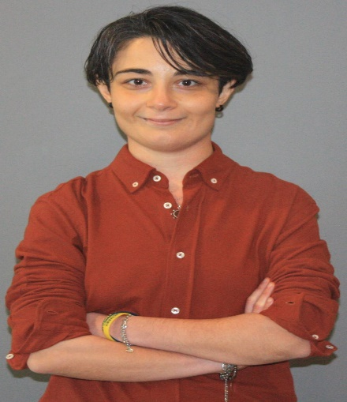
NAME: ZEKİYE
SURNAME: DAVAS
ADDRESS: MİTHATPAŞA CAD. ALİ DAVAS APT. NO:628 K:2 D:5 KÜÇÜKYALI/İZMİR
TELEPHONE: 0555 473 87 19
E-MAIL: zekiyedavas@gmail.com

PERSONAL INFO
DATE OF BIRTH: 23.03.1990
PLACE OF BIRTH: İZMİR
NATIONALITY: T.C.
STATUS: SINGLE
DRIVER LICENSE: B CLASS

EDUCATION
2004-2008: 60.YIL HIGH SCHOOL
2008-2014: İZMİR UNIVERSITY OF ECONOMICS/FACULTY OF ENGINEERING AND COMPUTER SCIENCES/SOFTWARE ENGINEERING

INTERNSHIP
2012: CMA Danışmanlık
2013: BUDO Yazılım ve Danışmanlık

JOB
AUGUST 2015-DECEMBER 2015: Zetaops Bilişim Teknolojileri A.Ş.
SEPTEMBER 2019 – OCTOBER 2019: I’ve worked on a project in BCC company between these dates.

Now I’m working for Telus International as a Content Moderator since April 2021.

FOREIGN LANGUAGE
ENGLISH (ADVANCED)
GERMAN (INTERMEDIATE)-B1 GOETHE CERTIFICATE

I’m also a freelance translator and doing translation from English/German to Turkish and from Turkish to English/German.

COMPUTER SKILLS
C, C++, C#, JAVA
SQL
PHP
MICROSOFT OFFICE
MICROSOFT PROJECT
HTML, CSS, PYTHON, ANGULAR.JS

HOBBIES
SPORTS

I’m very fond of different sports branches and I try to follow every current news and do researches. Besides, I’m a runner since 2016. I participate different running events like Wings for Life World Run, Izmir Marathon and Istanbul Marathon as I get a chance and time.

In Addition, I have a Personal Fitness Trainer Training Certificate from Başkent University Education and Consulting Center. I do 1-to-1 workouts with people who demand for getting fit.

2004-2008: 60. YIL HIGH SCHOOL BASKETBALL TEAM
2009: İZMİR UNIVERSITY OF ECONOMICS BASKETBALL TEAM

MUSIC
COMPUTER GAMES
BOOKS

STUDENT CLUBS
2009-2014: İZMİR UNIVERSITY OF ECONOMICS SPORTS CLUB
2010-2011: İZMİR UNIVERSITY OF ECONOMICS UNDERWATER CLUB
2013-2014: İZMİR UNIVERSITY OF ECONOMICS AVIATION CLUB
2011-2014: İZMİR UNIVERSITY OF ECONOMICS THE EQUAL PLATFORM CLUB

MY PROJECTS
2011-2012 SPRING:
COURSE: SE 315-SOFTWARE PROJECT MANAGEMENT: Fingerprint Student Attendance System
2012-2013 WINTER:
COURSE: SE 305- SOFTWARE SPECIFICATION AND DESIGN: Hotel Reservation System
SE 311- SOFTWARE ARCHITECTURE: Laundry Management System
SE 360- ADVANCES IN SOFTWARE DEVELOPMENT: Target GOALLL!
MATH 305- OPTIMIZATION: Cournot Problem
2013-2014 WINTER:
COURSE: SE 497- SENIOR PROJECT-1: E-MENÜM
SE 311- SOFTWARE ARCHITECTURE: E-Commerce System

TEB INSPIRATION EVENT PROJECT– Car Parking System Controlled by A Smart Phone
2013-2014 SPRING:
COURSE: SE 498- SENIOR PROJECT-2: E-MENÜM

