RESUME
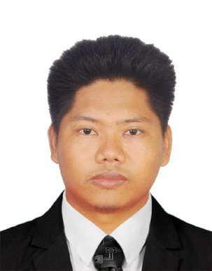 Zaw Htet Naing
No.9/4B, Yan Gyi Aung Street,San Chaung Township, Yangon, Myanmar.
Contact Phone No: +95 423830454,+95 946343747
Email: zawhtetnaingnaing@gmail.com

PERSONAL DETAIL

Name : Zaw Htet Naing
Father Name : U Tin Maung Oo
NRC No : 5/KaLaHta (Naing) 254547
Gender : Male
Date of Birth : 13 JAN 1995
Passport No : MG 651932
Marital Status : Single
Nationality : Myanmar
Race : Burmese
Religion : Buddhist
Country of Residence : Myanmar
Height : 5 feet 5 inches
Address : No.9/4B,Yaung Gyi Aung Street, San Chaung Township, Yangon
Contact Number : +95 423830454
OBJECTIVE
- My Objective in life is to live peacefully and harmoniously in the society helping the people who are underprivileged in all aspects; such as education, economy,social and so on.
- My duty in life is to upgrade my life to be better than my senior and to help the coming generation upgrade their lives to be better than mine.Thus,our generation will go up.
- To pursue highly challenging career, where I can contribute to the organizational goals there by simultaneously acquire new skills, fullest utilization of my knowledge to the organization’s growth.

EDUCATION

- Bachelor of Electronic Engineering-Kalaymyo University (2011-2016)
OTHER QUALIFICATIONS

- Advanced English at U Mya Kyaing English Language School
- Ielts 6.5
- Basic Computer skills
- Auto Cad 2D & 3D
- M&E
- YGE Training Center (Food&Beverage, Housekeeping)
TARGETED JOB

Apply Position :
Availability : Immediately
Expected Salary : Nego
SKILLS & KNOWLEDGE

    - PERSONAL SKILLS:
      - Comprehensive problem solving abilities, reasonable verbal and written communication skills, and ability to deal with people analytically to learn and team facilitator.

- LANGUAGES
- Four Skills in English

STRENGTHS

- Strong learner, able to increase responsibility and committed, highly initiative
- Critical thinking, good commonsense and Self-motivated
- Able to work under pressure and commitment to teamwork
- Strong organizational and communication skills

WORKING EXPERIENCE

- Assistant Teacher at NIEC International School (Jan-18 - Dec-19)
- Assistant Teacher at NELC for one year (Jan-19 – Dec-20)
- Interpreter at Mudita Foundation (German NGO) (Jan-21 -Dec-21)
- Open English Private School at home from 2021 to 2022
- Housekeeping Attendant at (Jasmine Palace Hotel –Myanmar) for one month
- Online Freelance English Translator from 2019 till now

INTERESTS
- Reading and writing in Burmese as well as English
- Hiking and camping in the forest
- Meditation
- Cooking
- Journalism English
- Political Science
- Singing
- Translating and Interpreting
---End of Resume---

