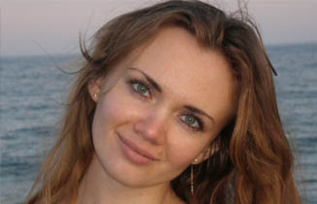
CV
YULIYA NIKOLAYEVA

Cell phone: +38 097 545 92 88 E-mail:mytranslatorua@gmail.com, yunick@rambler.ru

Languages:
- Russian
- Ukrainian
- English

Specialization:
- legal (the Articles of Association, agreements etc.), financial, banking documents;
- project and tender documents;
- business correspondence;
- reports, CVs, Quality Assurance documents etc.;
- personal documents (birth certificates, diplomas etc. )
- general texts.

Education:
2002 - 2007 . | Odessa National University named after I.I.Mechnykov, faculty of Romano-Germanic philology. Honours degree by specialty: “The Language and Literature (English)”.
Experience:
August 2010 – up to the present time | A freelance translator working with DIPLOMAT, LINGVOMIR, INTERPEREVOD, PROFESSIONAL, LINGVO EXPERT, ABCD GROUP, ABC GROUP OF COMPANIES, SIMWELL, INTEXT, A-FORMAT, AG-TRANSLATE, Lanta translation agencies etc. A freelance translator and interpreter for AFINA GROUP LLC, S-Engineering Ltd, Heat LLC etc.
April 2007 – August 2010. | “Lingvomir” LLC. Translator: legal, marine and personal documents. Interpretation during negotiations and conferences.
February 2006-January 2008. | “Odessa Business Center” LLC. Translator: business correspondence with foreign customers
October-November 2005. | “Levada” LLC – English interpreter for the period when the refrigeration equipment was installed.
October 2004 –July 2005 | “Plaske” JSC. Employed as a travel agent; completed “Аmadeus” basic training.

Additional information:
Birth date: 29.08.1985
Personal qualities: commitment and responsibility, ability to find compromises in any situations and a strong desire to develop my skills.
Software: SDL Trados 2011, Memsource Editor

