Yuliya Naturkach |  | 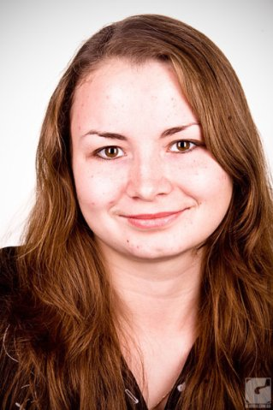
Age: | 29
Location: | Kiev, Ukraine
E-mail: | yuliya.naturkach@gmail.com

Translator
Professional Summary

Successful at maintaining meaning, flow and specific characteristics of original words when translating documents or spoken words. Able to converse easily in three languages. Background includes working in different environments to perform document and verbal translation services. Excellent listening and communication skills with an organized and systematic approach.

Work History

Translator
Jun 2014 - currently
Technolex Translations Studio
Kiev, Ukraine
- Replicated the flow, style and overall meaning of the original texts.
- Translated various documents from English to Russian and Ukrainian.
- Reviewed final works to spot and correct errors in punctuation, grammar and translation.

Translator
Jun 2013 – May, 2014
Advanced International Translations
Kiev, Ukraine
- Replicated the flow, style and overall meaning of the original texts.
- Translated various documents from English to Russian and Ukrainian.
- Reviewed final works to spot and correct errors in punctuation, grammar and translation.

Foreign Affairs Clerk
Apr 2011 - Feb 2013
Silence, Ltd
Kiev, Ukraine
- Business-related mailing.
- Negotiations.
- Translation of required documents.

Education

Ukrainian State University of Finance and International Trade (Kiev, Ukraine)
2011
Master’s degree in International Economics

Languages

English - Advanced
Italian - Intermediate
German - Elementary
Russian - Fluent
Ukrainian - Native

Дополнительная информация

Familiar with CAT-tools: Trados 2007, 2009, 2011, 2014, LEAF, LEAF 2013, Idiom, TWS/XLIFF Editor, Helium, Wordfast, Oddjob+MemSource, Transit, Translation Tiger, Across, Xbench, Linguistic Toolbox.

