CHIN YUK XAI
LANGUAGE TRANSLATOR / INTERPRETER
MANDARIN & ENGLISH

CONTACT ME
Address : 6613, Jalan Melur, Bagan Jermal, 12300 Butterworth, Penang, Malaysia.
Phone : +60174671101
Email : bell.yxchin@gmail.com
DOB : 6th July 1992
Gender : Male

EXPERIENCE
2017 - 2018
Language Line Solution
MANDARIN & ENGLISH INTERPRETER
Live interpreting under the world’s top intepreting service provider for medical, healthcare, government, law enforce- ment, insurance, finance, banking, tech, utilities, travel & hospitality, emergency services and general businesses.

2017 - Current TATI
HEAD OF PROJECT PLANNING
Entrusted as a key member of the management team to head and manage the overall functions of the project planning, development and businesses.

2018 - 2020 Exultant Group
HEAD OF SALES AND MARKETING
Entrusted as a key member of the management team to head and manage the overall functions of the Group’s businesses.

2014 - 2017 GSD Land
ASSIST. MANAGER, SALES AND MARKETING
Supporting the Sales and Marketing Manager in all aspects of the department. Maintaing productivity and achieving sales target.

2013 - 2014 BM City
SALES AND MARKETING EXECUTIVE
Supporting the Sales and Marketing Manager in all aspects of the department. Maintaing productivity and achieving sales target.

2010 - 2013
Woolley Development
ADMIN & CREDIT EXECUTIVE
Supporting the Branch Manager in all aspects of the depart- ment. Maintaing productivity and completing assigned tasks.

EDUCATION

PROFESSIONAL CERTIFICATE (2017)
LLS Mandarin and English, Medical: Level 4/5
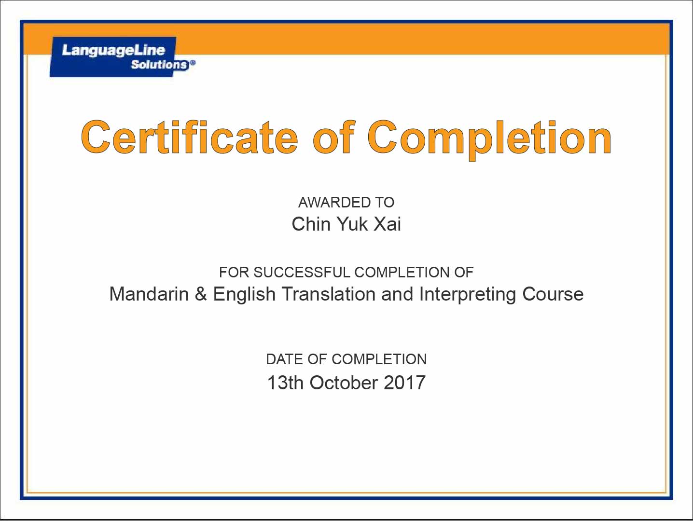

St. Mark School (2004 – 2009)
SECONDARY EXAMINATION (O-LEVEL)

Geographic translation. English to Mandarin.

中亚地区是典型的内陆干旱区，荒漠和半荒漠植被占绝了中亚平原地区的绝大部 分面积，其植物区系的发展变化与荒漠植被的演化过程存在密切关系。冰川期结束之 后的气候变化不仅在山地创造了新的植被类型，同时对平原植被的影响也具有方向性 的意义。大面积低地的逐渐干涸并随后开始的地面发展过程是第四纪中亚平原自然地 理环境变化的重要阶段。地表沙粘土冲积物上层受到强烈的风化作用，随着沙土的聚 集而逐渐形成了沙堆和沙丘。另一方面，随着冲积层表面水系和河谷的缩减，盐分的 运移过程加速，原来因河流冲刷而深埋在土壤基质中的盐分由于蒸发的作用开始向地 表的土壤层移动，这样因盐的聚集而改变了地表的地球化学基础条件。第三纪不同时 期从海水下出露的高平原非常清晰地描绘了这种变化，从周围低地隆起的高地必然地 受到周期性的侵蚀和地表冲刷作用，而与之相伴随的是各类风蚀活动。

Central Asia is the typical inland arid region. Desert and semi-desert plants has taken up the majority of the land mass in the flatland region of Central Asia, the development of its flora and fauna has a close relation to the evolutionary process of the desert vegetation. Climate change after the end of ice age has not only created new types of vegetation in the mountains, at the same time, the impact towards the flatland vegetation was directionally significant. The gradual drying up of large-scale lowlands and the subsequent land development process is an important phase for the changes of the natural geographic environment at Central Asia flatland in the Quaternary Period. The upper layer of alluvial deposit of sand and clay on the surface is exposed to strong weathering and with the accumulation of sand it gradually formed into sandpile and dune. On the other hand, following the reduction of the river system and river valley of the alluvium surface, the migration of salt accelerated, because of the salt that was buried deep in the soil matrix from to the eroding of rivers has begun moving towards to the surface layer soil due to evaporation, and due of the accumulation of salt, it changed the surface’s basic geometrical condition. The high plains from the sea water emersion in the different times of the Tertiary Period has very clearly depicted this change, the highlands rise from the surrounding lowlands will inevitably be affected by the periodic erosion and surface erosion, various wind erosion activities are also accompanied.

Medical translation. English to Mandarin.

Hepatocellular carcinoma (HCC), the main type of liver cancer in human, is one of the most prevalent malignancies in China and Hong Kong. The disease is a major cause of premature death and inflicts tremendous social and economic burdens on the Chinese. While a large number of treatment modalities such as surgical resection, transplantation and chemotherapy have been developed, these regimens are usually either only available for patients with early- stage HCC or mainly for palliation purposes. The disease is also particularly hard to treat because of late presentation and high tumour recurrence rates. Thus, we still are far from finding a cure for this disease.

肝细胞癌(HCC), 人类肝癌的主要类型，是中国和香港最普片的恶性肿瘤之一。这疾 病是夭折的主要原因并且也给中国人造成了巨大的社会和经济负担。尽管已经开发出 了多种的治疗方式例如手术切除、移植以及化疗，这些治疗方式通常适仅用于早期 HCC 患者或主要用于缓解的目的。这疾病也特别难治疗原因是病况呈现得晚和肿瘤复 发率高。因此，我们依然远离找到治愈这种急病的方式。

