**Peking University | Arabic (Bachelor)**

**2008.09-2012.06**

Majored in Arabic in the best university in China, had excellent grades (GPA3.72) and a solid language foundation. During sophomore year, got the Chinese National Arabic Professional Qualification Certificate. Used to work as an Arabic intern editor in the International Department of Xinhua News Agency.

**Cairo University | Arabic (Exchange Program)**

**2011.12-2012.01**

During my junior year, I studied at the College of Liberal Arts of Cairo University as an exchange student

**EDUCATION**

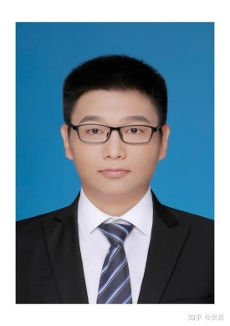

1. 10 years’ experience of Chinese-Arabic translation.

2. Study and work experience in Egypt and Tunisia.

3. Studied and graduated from the best university in China.

4. Now working as a senior Chinese-Arabic translator/interpreter in China's top language agency.

5.An average of 100,000 characters of Arabic to/from Chinese translation per year, and no less than 10 simultaneous interpretation for international and regional conventions.

6. High accuracy and extremely strict work attitude.

**Why you need me**

**International Department of China’s Multilingual Education Center**  **2012.07-present**

**Arabic Translator**

Working in the China’s top multilingual agency, I have deeply involved in Arabic translation interpretation and simultaneous interpretation and have quite a lot of experience on it. I also work as an Arabic language tutor and reviewer.

**China to Tunisia Embassy 2014.07-2017.01**

**Arabic Translator/Political Attache**

I have worked in Tunisia for more than two years, working as an Arabic translator, which helps me accumulate extensive experience in cross-cultural communication.

**WORK EXPERIENCE**

Chaoyang District

Beijing, China

bobestyy@163.com

936628777

**Wechat**

+8613426303033

**Moble/WhatsApp**

<https://www.linkedin.com/in/yang-yang-8b2a0486/>

**Linkedin**

Yang YANG

حكيم يانغ

Arabic-Chinese translator, interpreter, simultaneous interpreter

مترجم للعربية والصينية

Movies Table Tennis Music Photography Reading

**HOBBIES**

My mother tongue is Chinese and I have extensive experience in Arabic translation. I graduated from the best university in China, Peking University, majoring in Arabic. After graduating, I worked in the Chinese public sector. I have been engaged in Arabic translation and accumulated a wealth of translation experience.