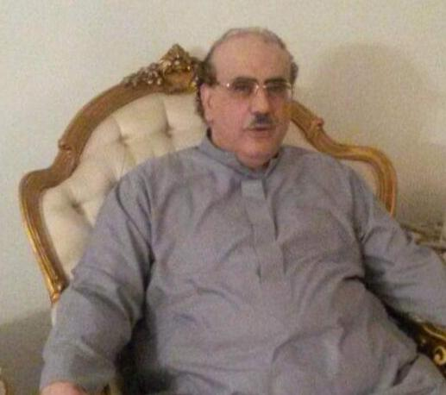  Contact  Saudi National ID 1064624255,  Born in Jeddah,  Saudi Arabia  Home Phone 0126195302  Mobile 0594325738  e-mail  waleed.f.hafiz@gmail.com  Address  3706 Aljeffeda unit 202  Jeddah, Mecca Province  23433 Saudi Arabia  Marital Status: Married with 4 children  Skills  - Translation from English to Arabic  - SAP Enterprise system  - ISO Quality assurance  - Monthly performance section report  Hobbies  - Internet Browsing  - Exercise  - TV watching | Waleed Hafiz  Objective  Organized and dependable candidate, willing to dedicate hours of hard work to complete the organization's tasks.  Work Experience  - I Started IT work at different companies for 20 years in Jeddah Saudi Arabia, since 2/1996 until 7/2016  - My last Job : Saudi Arabian Airlines at the IT division from 2/2003 – 7/2016  - I Started work in Saudi Airlines at SSKD (specialized skills development) section, to train IT employees) as an Instructor  I also got training in 13 different IT related topics.  - I moved to Customer service Microsoft Software Distribution to handle distributing MS software to Saudi Airlines employees and AHD Help  - Review of Saudi Airlines STC Bills with Saudi Airlines IT database,  - I worked part time for Al-Mutarjem certified translation office in Jeddah for 2 years handling different companies requests for English to Arabic translation.  - Then I joined IT IDS department, General manager office, Mr. A Alsaggaf.  My work included Translation from English to Arabic  the official brochures of two large Tamkeen and  IMCAN IT Projects and other materials.  - I joined the IDS OILS logistics section under Manager S. Albahkali and section Manager M. Alshagigi.  - I was the ISO OILS quality assurance representative.  - I made the IDS department Training plan preparation for all IDS employees.  - I was the OILS SAP Time keeper to record attendance of all employees in OILS JED, vacations, business trips, and training. I prepared the financial form in SAP for all expenses of the OILS employees trips and training for 6 years.  - I was promoted to Grade 19, And was the acting Manager for IDS OILS Logistics section, in the absence of Manager M. Alshagigi, for 3 years Until I was retired on 1/7/2016  - I worked for Al-Mehdar and Hammad Law firm on call for translation English to Arabic of the court rulings for different law suites. My work lasted 1 year and I am still on call with the office.  Education  - Bachelor of science : Architectural Engineering  At the University of Texas – at Austin, Texas 1984  - Courses in Computer Science at the University of Houston main campus - 1987  - Masters of Science Computer Science at the University of Houston Clear lake Texas G.P.A. 3.5/4 Honors 1990  - Courses in computer science Doctorate at Southern Methodist University –Dallas, Texas USA 1994. I finished all the course work, but the degree was not completed, GPA 3.8/4 Honors  - My English language improved a lot, since all my studies were using it.  Achievments  - Thank you letter from General Manager of IT IDS Mr. A. Alsaggaf for my work in 2009  - Man of the Quarter in IT IDS OILS section, chosen by Mr. S, Albahkali,. In the first Quarter of year 1434 for my work at the department.  - I made excellent in the yearly employee evaluation for 3 consecutive years since 1432 in IDS OILS Logistics section.  LINKEDIN  https://www.linkedin.com/in/وليد-حافظ-waleed-hafiz- 63861278
.

