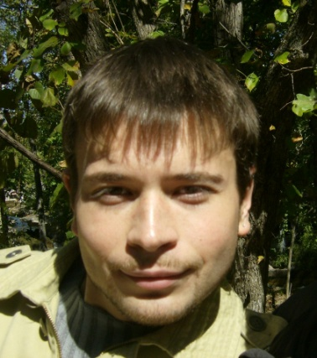**Translator / Interpreter**

1. **PERSONAL INFORMATION**

**Name:**

Grishin Vladimir Alexandrovich

**Rates:**

* **Written**

**0,05 - 0,10 $/word**

**15-30$/hour**

* **Consecutive Interpretation:**

**50-100$**

**Contacts:**

+7920 7831453

+7925 0631940

**e-mail:**

vlad_rabota@list.ru

grivlax_v@yahoo.com

**Residence:**

*Tula and Moscow, Russia; Nixa, Missouri, USA.*

1. **WORK EXPERIENCE**

**Employment period:** August, 2008 through May,2009

**Employment position:** Language Instructor (full time)

**Company:** Misosuri Southern State University,, г.Joplin, Missouri, USA

**Employment period:** September, 2004 through August,2008

**Employment position:** Language Instructor (full time)

**Company:** Tula State University, Department of Liberal Arts, Chair of

Linguistics.

**Employment period:** September, 2004 through July, 2008

**Employment position:** Translator (shared position)

**Company:** Centre of Translations., Tula, Russia

**Company’s work field:** Translation and interpretation for individual and corporate

customers.

**Professional duties:**

*Translation:*

* **SDL Trados 2007**
* **PROMT Expert 8.5**
* **IN doc.’s format**

**- Translation areas**:

* **Economy** (agreements, contracts, commercial correspondence, business letters, faxes, bank payments, bills etc.)
* **Law** (agreements, contracts, claims, complaints, copyrights, administrative documentation etc.),
* **Notary** (letters of attorney, testimonial letters, apostils etc.),
* **Oil and Gas** (on-site pipeline, drilling and well abandoning specifications; legal support documentation),
* **Agriculture** (general),
* **Psychological trainings** (in sales, management, etc.),
* **Medicine** (general),
* **Pharmacology,**
* **Make-up and Perfumery.**
* **IT** (Microsoft-programs, computer games etc.)
* **Scripts** (videos, commercials, cartoons etc.)
* **Chemistry** (general)

**Interpretation**:

* **Consecutive** (negotiations, escort, workshops etc.)

1. **EDUCATION**

**University:** Missouri Southern State University (Joplin, Missouri, USA)

**Graduation:** May,2009

**Department:** Foreign Language Department / Language Department

**Major:**  Non-Degree (Spanish, Arabic, Newswriting (English), Oral

Communication (English)

**University:** Tula State University (Tula, Russia)

**Graduation:** July, 2004

**Department:** Humanitarian, Chair of Linguistics.

**Major:** Linguist. Translator / Interpreter. Language Instructor.

1. **ADDITIONAL TRAINING**

**Training course:** The Fulbright FLTA

**School:** International Institute of Education (IIE), New York, NY,USA;

Brown University, Providence, RI, USA., г. Washington, DC, USA:

Providence, RI, USA.

**Period :** 10 months

**Termination date:** May, 2009

**Training course:** Italian

**School:** International Police Association, Tula, Russia

**Period:**  2 years

**Termination date:** June, 2002

1. **LANGUAGE PAIRS**

English-RUSSIAN

Russian-ENGLISH

German-RUSSIA

French-RUSSIAN

Italian-RUSSIAN