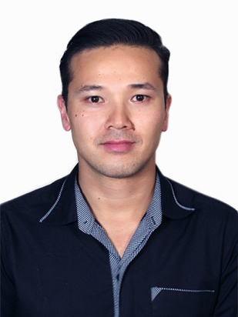
Victor Yamato

289/687 The Base
Sukhunvit 77 On Nut 1/5
10110 – Bangkok Thailand
(66) 097-0756-153
victoryamato2@gmail.com
37 years old Single

Objective: Translator/interpreter

Experience in convert written material from one or more 'source languages' into the 'target language', as I’m qualified for English, Japanese, Spanish, Portuguese, ensuring that the translated version conveys the meaning of the original.
Experience in transcreations, which is a mix of translation, localization and copywriting, where the text is culturally and linguistically adapted to suit the reader.

Skiils

- reading through original material and rewriting it in the target language, ensuring that the meaning of the source text is retained;

- using Translation Memory software, such as Wordfast, memoQ, across, SDL Trados and Transit NXT, to ensure consistency of translation within documents and help efficiency;

- using specialist dictionaries, thesauruses and reference books to find the closest equivalents for terminology and words used;

- using appropriate software for presentation and delivery;

- researching legal, technical and scientific phraseology to find the correct translation;

- liaising with clients to discuss any unclear points;

- proofreading and editing final translated versions;

- providing clients with a grammatically correct, well-expressed final version of the translated text, usually as a word-processed document;

- using the internet and email as research tools throughout the translation process;

- prioritize work to meet deadlines;

- providing quotations for translation services offered;

- supplying subtitles for foreign films and television programs;

- retaining and developing knowledge on specialist areas of translation;

- following various translation-quality standards to ensure legal and ethical obligations to the customer;

- networking and making contacts.

Academic education

Degree in Business Administration - Completed in 2011
Unip Universidade Paulista – Sao Paulo – Brazil

Konan High School, Hamamatsu-chi – Shizuoka-ken Japan (1997 – 1998)
Kami Fundamental School, Hamamatsu-chi – Shizuoka-ken, Japan (1995 - 1996)

Languages

English – Fluent
Spanish – Fluent
Japanese – Fluent
Portuguese – Fluent

International Experience

Japan – Brazil – Spain – America – I have lived in all these countries for some times of my life
World Wide – Professional experience as flight attendant in many countries around the world

Professional experience

- 2015 to 2018 Freelancer Translator in some translation companies around thailand

- 2016 to 2018 Sigma Prep Center – Bangkok - Thailand
Translator/Interpreter
Japanese Teacher
General English
Courses Consulter
Management Administrator
Marketing
Spanish Teacher

- 2010 to 2018 Freelance Translator/Teacher/Interpreter

- 2010 to 2016 Gol Airlines – Brazil

Flight Attendant Master position
Instructor of technic course for Aviator Subjects
Master checker at language department
English/Japanese/Spanish Proficiency Instructor for aviation

- 12/2001 to 06/2007 Nakamura Hakken Gaisha – Hamamatsu-chi - Japan
Company responsible in the recruitment and selection of people for outsourced companies

Administrative Manager
Supervisor Administrative
Assistant Administrative

- Performance in administrative analysis, definition of goals, realization of visualizations and monitoring of the work employee, elaborating actions to increase the results.

- Responsible for the creation of plans and management projects for optimization of resources, evaluating a board of directors in administrative and functional supervision.

