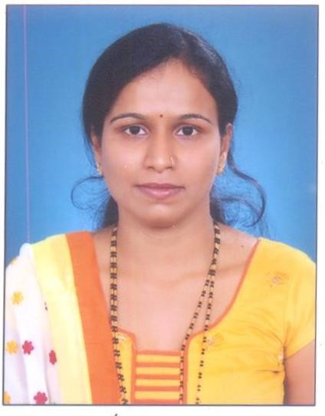
Veena G Anchan
Phone: +91 7019284297
Email: veena.ask@gmail.com

OBJECTIVE | “To secure a challenging position where I can effectively contribute my skills, with a long term career potential and to serve for the advancement of the Organization.”.

WORK  EXPERIENCE | - IT Support Engineer for one year and three months in BCS Pvt Ltd Banshankai Bangalore, KA.  - Application Researcher for nine months and a Transaction Processing Officer for two years in Mphasis Mangalore, KA.  - Center Administrator for three years nine months in Tobacco Control Capacity Programme (International Project) at Manipal Academy of Higher Education, KMC, Manipal, KA.  - Part time language translator at Crescendo Transcriptions Pvt. Ltd (Nov 2019 to Oct 2022)- English to Kannada translation  - Currently working as a Project Assistant in PRESCRIP-TEC(HORIZON 2020) Project at Manipal School of Information Science, Manipal Academy of Higher Education, Manipal, KA (since January 2022).

ROLES &  RESPONSIBILITIES AT CURRENT JOB | Roles & Responsibilities at the Current Job:  - Performing bookkeeping tasks such as invoicing, and budget tracking.  - Data collection (field work)  - Data entry and quality checking  - Schedule online/offline meetings, and the conference room in order to prevent duplicate bookings.  - Maintaining general office files, including job files, vendor files, and other files related to project.  - Purchasing office supplies, equipment’s.  - Overseeing the maintenance of office facilities, and equipment.  - Manage agendas/travel arrangements/appointments etc. for the upper management  - Language translation (Kannada to English) and quality checking  - Transcription of audio files

EDUCATION | Bachelor in Computer Applications from Mangalore University

ACADEMIC PROJECTS | Project Title : Dynamic Website Development  Technologies : Apache Server, Joomla Tools and MySQL (Database)  Project Title : Student Result Management System  Technologies: Java and MySQL

SOFTWARE SKILLS  TRAININGS | C, C++, JAVA  Oracle 9i, MySQL, NVivo  HTML, Joomla Tools  MS Word, PowerPoint, Excel, Access, Outlook  - Training on creating themes and subthemes in NVivo  - Training on Hardware and Networking (Assembling & Disassembling a PC, Server Installation)  - Worked as Hardware and Networking Theory Trainer for 3months

LANGUAGES KNOWN | English, Kannada, Hindi, Tulu

DECLARATION | I hereby declare that the above-written particulars are true to the best of my knowledge and belief.

Date : 05.03.2024 
Place : Udupi Veena G Anchan

