Valeriia Nagorniak

Date of birth: 14.05.1993
Krasnodar city
E-mail: n.vasantarasa@gmail.com

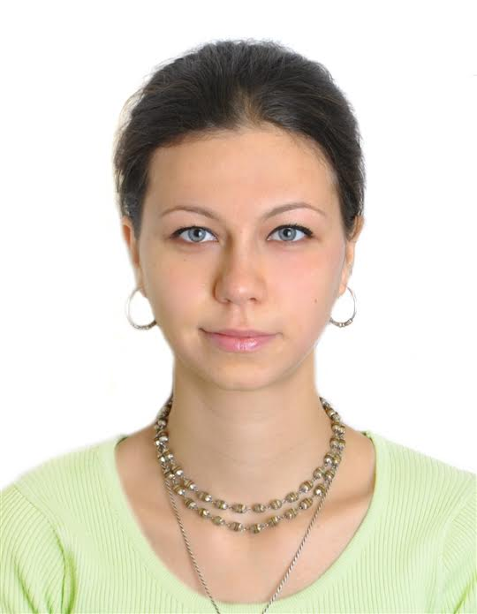

Objective: Obtain a translator.
Education: Specialist travel services
Additional education: head of the tourist group, a makeup artist, photographer, translator.
Experience:
Interpreter
• Performing oral and written translations
• Foreign citizens (abroad both Russian and English-speaking) activity has been connected with various branches in the sphere of culture, fashion, excursions, medical aspects, as well as cosmetics.
Professional skills:
• Literacy speech and writing
• Confident PC user
• Possession of office equipment
• Knowledge of business communication etiquette
• Languages: English, Russian
Personal qualities:
• Communication skills
•A responsibility
• Mindfulness
• Orderliness
• Excellent diction
• Excellent memory
• Ability to learn quickly
Additional information:
Marital status: Married

