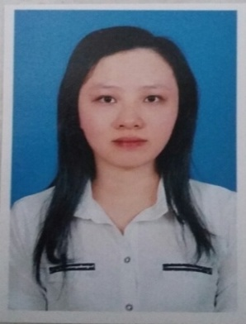 Tran Thi Ngoc Tram
Translator - Content Editor
Personal Details
Date of birth : 03rd October, 1992
Contact address: 220/9 Ho Van Hue, Ward 26
Phu Nhuan District, Hồ Chí Minh City
Phone number : 0120-464-4143
E-mail : tranngoctram.310@gmail.com

Qualifications
Bachelor of Arts in English language - Ho Chi Minh City Open University
2010-2014

Certificate
TOEFL ITP: 563/677

Work experience
- Part-time Translator – Thien Minh Group
January 2011 – January 2015
Translate and edit English documents about skin care, health care, nails care, weight loss,… into Vietnamese versions.

- Full-time Subtitle Translator - Thao Le Entertainment Company
June 2014 – March 2015
Translate and edit English subtitle for shows, films broadcasted on Star World, Asian Food Channel, Davinci, Outdoor Channel,...into Vietnamese.

- Part-time Translator - Phu Nu Nguoi Lao Dong Newspaper
January 2015 – February 2016
Translate English articles about women’s health care into Vietnamese versions.

- Part-time Translator - Optimist Company – Website Picnictoy.vn
April 2015 - February 2016
Translate English articles about how to play with and teach kids, about benefits of play and toys into Vietnamese versions.

- Full-time Translator – Dong Thai Import And Distribution Company, Ltd.
October 2015 – July 2017
Translate, edit articles about herbals, vitamins, health care,...
Translate subtitles for videos about Sales.
Support office tasks.
Build website Voila-blog.vn and store.voila.vn

- Part-time Translator – WIKIHOW.COM
November 2015 – January 2018
Translate, edit articles instructing how to do everything in daily lives.
Build website Wikihow.vn

- Full-time Translator & Sales Admin – PROVESTIA Company
August 2017 - Present
Translate, edit articles about pregnancy, herbals, vitamins, health care, information about cosmetics, supplements...
Support office tasks.
Build website Karethy.com; Voila-blog.com and hoclam.me

- Part-time Subtitle Translator - INJESTAR Company
January 2018 – Present
Translate and edit English subtitle for Japanese shows into Vietnamese.

Special skills
Good at both individual work and group work
Skilled at researching and gathering valuable information
Familiar with MS Word, MS Power Point
Able to work under pressure
Eager to listen and learn

Languages
Vietnamese (mother tongue)
English (good)
Korean (some)

Activities attended
- The Seminar Learn the secret to learn English Fast at Wall Street English
- The Seminar Soft Skills Training Series: Jobs Searching Skills at The American Center
- MOOC Camp Analyzing Global Trends for Business and Society at The American Center

Interests
Watching movies, listening to US and K-Pop music, reading online newspaper,...

References
Mr. Hoan - Provestia Company - Manager
Phone number: 090.360.4409

Mr. Tuan – Thao Le Entertainment Company - Coordinator
Phone number: 090.226.3523

