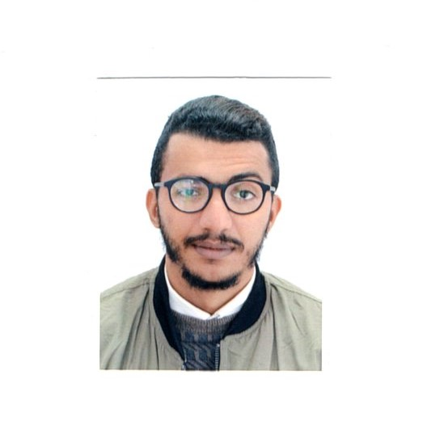
TOUIDJINE MOHAMED AMINE
e-mail- lafofe13@gmail.com , Ph No+213676819607
# 134 CITY Bouanani Abde nour ,Ain témounchent, Algeria,46000
_________________________________________________________________________
Objective: Seeking a challenging position in your esteemed organization where my creative liaison and co-ordination skills can be effectively utilized to improve operations and contribute to the company’s growth.
Personal Skills:
- Good verbal and written communication skills
- Ability to work hard
- Ability to build motivation
- Creative & self-confident
- Positive approach thinking
Educational Qualification:
- 2011: Bacaloriat
Specialty: Management and Economics
Mention: Fairly-Good
- 2012: Bac +1
Specialty: Management Science and Economics
Mention: Good
- 2016: License
Specialty: English language.
Mention: Good
- 2017: Master 1
Specialty: English Linguistics
Mention: Good
- 2018: Master 2
Specialty: English Linguistics
Mention: Very Good

SOFT SKILLS:
- Basic in computers
- Creative art work
- Manipulating editing software
- Speaking French Arabic Germen And a bit Spanish

WORK EXPERIENCE:

• (2014-2016): Radio station Host
• (2016- ...): Teaching English teacher support "At Home"
• (2017- ...): Supports English teacher at the International Linguistic Center Berrichi Ain Temouchent.
• (2017-2018): An English teacher at Berrichi Ain Temouchent International Linguistic Center.
• (2017-2018): An English teacher at International Linguistic Center Inas Ain Temouchent.
• (2018- ...): A professor of culture and civilization at the Department of Latter and Foreign Languages ​​(English) at the University Center Belhadj Bouchaib Ain Temouchent.
• (2018- ...): An English teacher in the Department of Subject Science at Belhadj Bouchaib Ain Temouchent University Center.
• (2018- ...): An English teacher in the Department of Economic Science and Management at the University Center Belhadj Bouchaib Ain Temouchent.
• (2018- ...): English Lecturer for PhD students in Mechanical Engineering and Civil Engineering at the Belhadj Bouchaib Ain Temouchent University Center.

Personal Details:

Father’s Name : Nor Ed-Dine Touidjine
Mother’s Name : Fatiha Touidjine
Date of birth : 16th July 1992
Sex : Male
Marital Status : Single
Nationality : Algerian
Hobbies : Listening and playing Music, Craft work, drawing, reading and writing.

DECLARATION :

The above mentioned information is true and correct to the best of my knowledge and belief. If I am selected and given a chance to serve in your esteemed organization I shall prove my best and ability to the entire satisfaction of my superiors.

Yours faithfully
(Touidjine Mohamed Amine)

