TOMASZ SENDA  Date of birth: 14 march 1996  Place of accommodation: Puńsk  E-mail: tmsdsd@gmail.com  Phone number: +48 607348391 | 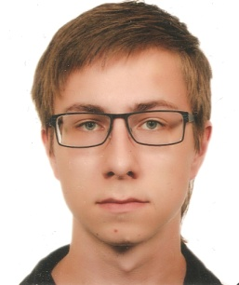

Education
2012.09 | - still | Lithuanian Upper-secondary School of 11 March in Puńsk
2009.09 | - 2012.06 | Lower-secondary school of Darius and Girenas in Puńsk
2003.09 | - 2009.06 | Elementary school of Darius and Girenas in Puńsk
Languages
russian |  | average
french |  | intermediate
english |  | intermediate
lithuanian |  | native
polish |  | native

SKILLS
Driving licence |  | cat. B
Computer skills |  | MS Word, Exel, PowerPoint, the basics of html language

INTerests
literature, folk dance, modern dance, foreign languages, theater, travelling, music .

