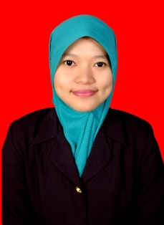
Curriculum Vitae
Personal Data
Name | Timur Paramitasari, S.Pd
Place, date of birth | Jakarta, Oktober 9th 1990
Sex | Woman
Nationality | Indonesian
Religion | Islam
Marital Status | Single
Address | Jetis Kauman RT.02/12 Kel.Parakan Kauman Kec.Parakan – Kab.Temanggung, Central Java (56254)
HP | 085 878 787 316
Email | timur.paramita@gmail.com
Health | Excellent
Height | 157 cm
Weight | 50 kg
Education Background
2009-2014 | Bachelor of English Education, The State Islamic Institute (IAIN) of Surakarta, GPA 3.32
Work Experience
Job Experience
2012 | English Teacher in Madrasah Tsanawiyah Negeri (MTsN) Ngemplak - Boyolali
 | Duties : teaching English lesson to seven grade and eight grade students
2015 | Teacher in Fatimah Az Zahra Kindergarten Parakan
 | Duties : teach basic skill such as color, shape, number and letter recognition. Observe and evaluate children’s behavior, performance, social development, and physical health.
Business Experience
2014 | Self-employed (selling food from home industry to consumer)
 | Duties : taking the product from the producer, selling and marketing the product to consumer, corresponding with producer and consumer, billing and market research.
Language
Native | Indonesia
Advanced | English
Computer Skill
Advanced | Microsoft Office
Basic | Adobe Photoshop

