RESUME

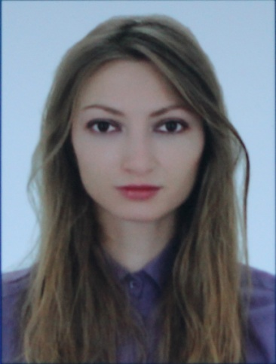

Tetiana Barabash
Ivano-Frankivsk 76000
Ukraine
Phone: +380934980533
Email: meinesmeer@gmail.com

EDUCATION
(1.09.2010-3.08.2014) Ivano-Frankivsk National Technical
University of Oil and Gas
Institute of Technical Translation
and Records Management
Department of Philology and translation
Area of specialization: Technical translation (Bachelor)

(1.09.2014-30.06.2015) Ivano-Frankivsk National Technical
University of Oil and Gas
Institute of Technical Translation
and Records Management
Department of Philology and translation
Area of specialization: Technical translation (Master)
(Diploma with honors)

Expected graduation date: June 30th, 2015
Courses taken:
- Communication Theory
- Pedagogy
- Translation Studies
- Country Studies
WORK EXPERIENCE
(October 2012- May 2013) Teacher of Ukrainian for foreign student by means of English within the field practice
Responsibilities:
Search of teaching materials;
Presenting of materials;
Controlling and testing of students

(2012-2014) Translator for foreign students within the field practice

Responsibilities:
Informational support of the group; interpreting of studying
and practice process; organizing of excursions and escort
services; assistance with documentation formulating.

(February 2014, February 2015) Teacher of English in Physical and Technical Liceum at Ivano-Frankivsk
National Technical University of Oil and Gas

Responsibilities:
Search of teaching materials;
Presenting of materials;
Controlling and testing of students
Organizing of out-of-school activity

(May 2014) Translator within the field practice in Chełm (Poland)

Responsibilities:
Translating of educational, research
and methodology materials
Attending of literature lessons
at the Państwowa Wyższa Szkoła Zawodowa

(2014-2015) Private teacher of English for children

Responsibilities:
Search of teaching materials;
Oral and written translating;
Controlling and testing of pupils

(June 2015) Assistant in CENTRE OF TEACHING FOREIGN STUDENTS in Ivano-Frankivsk National Technical
University of Oil and Gas

Responsibilities:

Assistance and verification of documentation

LANGUAGE SKILLS
Ukrainian (native speaker)
Russian (fluent)
English (fluent)
Polish (good)
German (fair)

COMPUTER LANGUAGE SKILLS
Microsoft Office, Microsoft Word, MS Power Point, MS Publisher

COMMUNICATIONAL SKILLS
High-level organizational and time-management skills
Ability to work unsupervised and as part of a team
Strong verbal and personal communication skills
Accuracy and Attention to details, punctuality
Critical thinking, decision-making and problem solving skills
INTERESTS
Travelling, chess, photography, music, foreign languages

References
Available upon request

ADDITIONAL ACTIVITY
Translating for Public translation project “Vavilonska biblioteka”

