RESUME

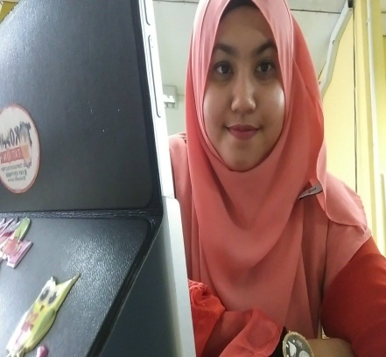

TANIA MOHAMAD
Lot 2025, Lorong Meranti, Tanjung Mas,
Jalan Pengkalan Chepa, 15400 Kota Bharu,
Kelantan.
H/p no: 019-4275746
tania_becks@yahoo.com

_________________________________________________________________________________
PERSONAL DATA:

DATE OF BIRTH : 20TH MAY 1992

AGE : 24

MARITAL STATUS : SINGLE

TARGET : To become a professional (freelance) translator for multi languages

EDUCATION / LEARNING CENTRE:

2013-2016 : BACHELOR’S DEGREE IN EDUCATION (TESOL), UNIVERSITY OF AUCKLAND
2010-2012 : A LEVEL COURSE, MARA COLLEGE SEREMBAN
2005-2009 : ISMAIL PETRA HIGH SCHOOL, KELANTAN.
YAMAHA MUSIC SCHOOL, KELANTAN.
OXFORD LANGUAGE CENTRE, KELANTAN.
1999-2004 : ISLAH PRIMARY SCHOOL, KELANTAN.
YAMAHA MUSIC SCHOOL, KELANTAN.

LANGUAGES :

-MALAY (NATIVE SPEAKER)
-ENGLISH (ADVANCED)
-SPANISH (BEGINNER / BASIC)- Completed until beginner 2 stage at University of Auckland.
-KOREAN (BASIC-ABLE TO COMMUNICATE /ABLE TO READ AND WRITE KOREAN HANGUL- ALPHABETS)- Completed Beginner 1 stage at University of Auckland.

AWARDS:

-Highest achiever in English subject, 2008 (Ismail Petra High School)
-Best performance during Yamaha Piano Mini Concert

WORKING EXPERIENCE :

-Freelance translator
-Retail assistant
-Freelance in doing assignment proofread for engineering students
-Internship in English teaching to ESL students (non-native speakers) at Mt Roskill Grammar School, Auckland, New Zealand.
-Currently doing an internship at MRSM Kuala Terengganu in English teaching for three months

SPORTS ACTIVITIES :

-Futsal player for Bersatu Games for Malaysian students, University of Auckland, 2015
-Active in volleyball

VOLUNTEER / SOCIAL WORK:
-Mentoring program for primary kids at Mansell Senior School, New Zealand.
-Volunteering work at Auckland Council, New Zealand

SKILLS :

-Translate general articles from English to Malay and vice versa
Other fields of translation might include : Education, music, beauty and health, entertainment (dramas and TV shows)
-Capable to use Microsoft Word and other computer skills.
-Human translation is guaranteed

INTERESTS :

-Foreign languages and translation.
-Would like to learn using translation software if required by company

REFERENCES :

SHERYL MCINTOSH
Lecturer, University of Auckland.
sa.mcintosh@auckland.ac.nz

