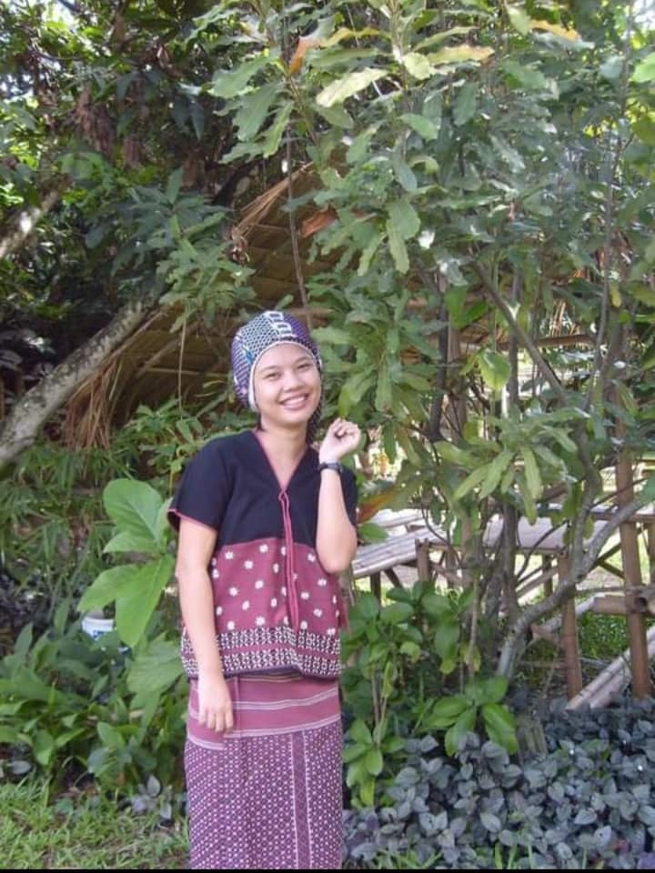 |  | Tin Tin Naing@Naw Dalia Dee  Interpreter/ Translator  Freelencer  Passionate multilingual translator with 10 years' experience in English<>Karen/Burmese translations in NGO's field and over 2 years with freelancer translations. Linguaphile from early childhood. Successfully translated over 200 complete projects, ranging from documents to entire websites. Looking to further improve translation skills by becoming the head translator at your company.  Work Experience  English-to-Karen(S'gaw)/Burmese Translator (Freelancer)  November 2018–Until now  Key Qualifications & Responsibilities  - Performed various translation English<>Karen/Burmese, including written texts, localization, internationalization and audio record.  - Translated text projects, including legal documents, and corporate reports.  - Upheld strict confidentiality policy when translating personal and diplomatic materials.  Education  Bachelor of Arts in English  Yangon, University, Myanmar  Graduation: 2004  Key Skills  - Excellent Verbal, Non-Verbal, and Written Communication  - Cultural Awareness & Intelligence  - Time Management & Multitasking  - Analysis & Research  - Self-Management & Self-Motivation  - Creative Writing Skills  - Copywriting & Copyediting

Tin Tin Naing
@
Naw Dalia Dee
Translator/Interpreter

CONTACT
PHONE:
+66-640107248

EMAIL:
d.dee.d246@gmail.com

Current Address: 222, Moo 3, Mae Pe, Mae Sot, Tak, Thailand

Permanent Address: No.17, U Aung Kyaw Rd, E.Gyogone, Insein, Yangon

