СV
Objective | Job of a free lance translator

Svitlana Skrypchuk | 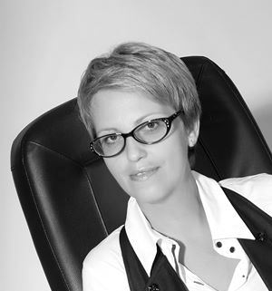
Kv.188, #31 prospekt Myru, Kryvyi Rih,
Dnipropetrovs’ka oblast, Ukraine 50074
T: mob. +380962318222
home:+380564749309
E: sv3tas@gmail.com
Skype: bonyara55

Summary | A pro-active person who has a relentless drive to have a broad impact rather than just deliver results. Possessing experience of translating and interpreting English to Russian/Ukrainian and vice versa, providing clear guidance and leadership to a team and ensuring that all legislative requirements are fully met. As a professional educator, a confident communicator with strong interpersonal skills. Interested in doing translations of various types for a supplementary income

Skills |  | Professional | Personal
 |  | Meeting important deadlines | Strategic thinking
 |  | Leadership skills | Conflict resolution
 |  | Information gathering | Problem solving
 |  | Follow up | High levels of integrity
 |  | Conscientiousness

Work history | Period |  | Position | Responsibilities
 | September, 2006—present  2015-2016  2005-2006 |  | A teacher of English, a chair of Foreign Languages Dept at school # 4, Kryvyi Rih  An interpretor for a project of ICLD (Sweden)  Full time interpretor and translator for Mittal Steel Company Kryvyi Rih | - Giving lessons of English  - Defining project scope, objectives, milestones & deliverables  - translating, proofreading & reviewing, etc  - interpreting at the workshops and meetings within the agenda  - translating documents  - interpreting at the meetings and negotiations
Education & Trainings |  | Period | Institutions |  | qualifications
 |  | May 2014 – December 2015 | ICLD ITP Local Political Leaders – Capacitating Women in Politics |  | Alumnus (Certificate of Completion)
 |  | June 2005 – August 2005 | American Councils, TEA (Excellence in Teaching Award) funded by U.S. Dept of State |  | Alumnus (Certificate of Achievement)
 |  | September 1986 – June 1991 | Local Pedagogical University |  | A teacher of English (Diploma)

Languages | English (fluent), Ukrainian (fluent), Russian (native speaker)

Tools used for translation SDL Trados, J-CAT
References | On request  Ms Kristin Ekström  Programme Officer, ITP  Phone: +46 (498) 29 91 46  E-mail: kristin.ekstrom@icld.se

