Resume 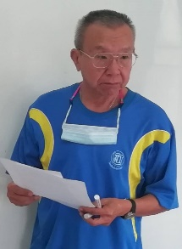

Objectives
To​ utilize my​ 40-year​ business​ practice in​ English​ translation, interpretation, correspondence, and​ teaching.

Name: Mr.​ Supak​ Kudidthalert​
Phetchabun, Thailand
Tel.​ & Line: 0897994491​
Email: supak91@hotmail.com​

Jobs required
Translation​ :
English​ to​ Thai​
Thai​ to​ English​

Experience
2005-2020 Owner and​teacher, English​ tutorial house​ for​ secondary and​ high​ s​chool​ students.
1995-2004 As​ a​ freelancer​ on​ export​ marketing.​ Located and​ developed overseas​ clients for​ Thai​ food manufacturing​ companies.
1988-1995 Worked​ at​ executive level with​ various​ Thai​ and​ foreign companies.
1977-1988 Served as​ Marketing​ Officer with​ the​ New​ Zealand​ Department of​ Trade​ and​ Industry, based in​ Bangkok​ at​ the​ New​ Zealand​ Embassy.

Education
1977​ B.Sc.​ Chulalongkorn University
1983​ MBA Thammasat​ University

Others
Proficient in​ academic and practical English.

