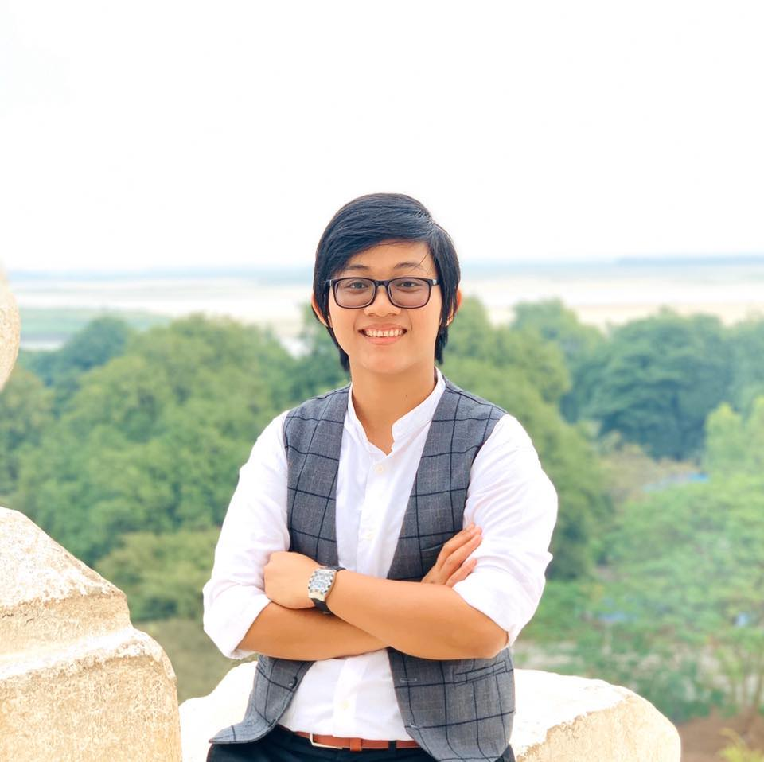**CURRICULUM VITAE**

NAME Ms. Su Wai Phyo

NRC NO 12/Ou Ka Ta (N) - 187649

AGE 9/July/1991

ADDRESS No (186), Kawliya (26) Street, (13) Block, South Okkalapa Tsp., Yangon, Myanmar.

PHONE NO 959-421070758

Translation Tools EC Innovations’internal translation software, Trados

Language Pair English-Burmese and Burmese-English

Specialization Education, Economy, Legal documents, Governance, Business, Women Rights, Gender, Politics, Technology, Health, Peace-building.

E-MAIL [suwaiphyo1920@gmail.com](mailto:suwaiphyo1920@gmail.com)

OCCUPATION Freelance Interpreter/Translator

**EDUCATION**

1. **Post Graduate Diploma in Creative Writing and Editing** December, 2018 - September, 2019

(Department of Myanmar, University of Yangon)

1. **Diploma in Intellectual Property Law** June, 2018 – April, 2018

(Department of Laws, University of Yangon)

1. **Master of Public Administration** Aug, 2014 – Dec, 2015

(Aldersgate College, Philippines)

1. **Diploma in Political Science** Dec, 2014 – Sep, 2015

(Department of International Relations, University of Yangon)

1. **Certificate Course in Social Entrepreneurship** Jan, 2012 – Apr, 2012

(Myanmar Egress)

1. **Bachelor of Business Management** Dec, 2007 – Sep, 2011

(Yangon University of Economics)

**CAREER EXPERIENCES**

|  |  |  |  |
| --- | --- | --- | --- |
| Organization Name | Position | Major Duties and Responsibility (Project Name) | Contract Duration |
| Social Impact Inc., | Interpreter | **Evaluation on Civil Society and Media Project of FHI-360**  Provide Burmese-English interpretation for SI employees and consultants in meetings with local relevant stakeholders/ Support preparation of a data collection plan, specifically assisting the team in planning the logistics for a detailed data collection schedule and translating data collection protocols into local languages, as needed/ Prior to fieldwork, support preparation of fieldwork logistics, such as hotel, ground transportation, and arranging meetings, under direction from the Team Lead and Social Impact management team/ During fieldwork, support key informant interviews (KIIs) and focus group discussions (FGDs) with identified stakeholders in Myanmar, through either interpretation or note-taking, depending on the team’s needs./ Transcribe recordings of interviews from Burmese to English./ Other logistical/administrative tasks as assigned./ Work closely with SI HQ team and communicate in a timely and effective manner with all project personnel. | October, 2020 to June, 2022. |
| FHI-360/USAID | Freelance Interpreter | * Translating the documents relating with Civil Society and Media Project such as Inclusion and Gender Policy Paper. * Interpreting in all of the meetings, seminars, workshops and training all over the country | 1, May, 2018 to 1, May, 2023 |
| BEIERSDORF GLOBAL | Translator | * Translating the documents relating with marketing tools and skin care handbooks for the products of BEIERSDORF GLOBAL which are Nivea and Hansaplast. | 1, June, 2017 to 1, May, 2024 |
| International Rescue Committee | Translator | * Translating of the related documents of the programs. | 1, September, 2021 to 31, August, 2022. |
| United Nations Development Plan (Myanmar) | Freelance Interpreter/Translator | **Local Governance Project**   * Interpretation Services - Provide simultaneous/consecutive interpretation during steering committee, technical working group meeting, workshops and trainings, conference, meeting between the international advisors/experts and national consultants as well as national counterparts. * Translation Services – Translation from Myanmar to English and vice versa of various reports, documents, presentations, manuals; legislation, advocacy and information materials, documents of meeting of working groups, correspondence to the government, national counterparts and international partners, producing the 100% accurate translation of English test to Myanmar or vice versa, making necessary corrections for changes required by the organization and re-submitted correct text within agreed timeframe. * Proofreading – edit, check and correct for English to Myanmar translation work and vice versa. Quality check and proofreading of translation ensuring no typos, errors in the final text, ensuring timely delivery of translated and edited materials. Assure translations are correct and consistent in terms of completion, terminology usage, correct meaning, correct Myanmar Grammar and Spelling. * Note Taking – take notes at meetings/conferences and provide meeting minutes/report in English. | 1, May, 2018 to 1, May, 2023 |
| Mckinsey&Company | Translator | Branch Transformation and business development for YOMA Bank | May, 2018 to May, 2020. |
| UN Women | Translator (Container) | Translation materials from English into Myanmar and Translation materials from Myanmar into English Gender Responsive Governance, Peace and Development. | 27, September, 2018 to 29, October, 2020. |
| Cardno Myanmar | Interpreter/Translator | Myanmar Education Quality Improvement Program (MyEQIP) | July, 2018 to 24, Jan, 2020. |
| Social Impact Inc., | Interpreter | Supporting the team with interpretation and translation services, as needed. The Associate will accompany the team to conduct data collection, providing English interpretation for team members who are non-native Burmese speakers. These services may not be required at every interview or on every day. The Associate will work closely with the Team Leader to determine ahead of time which meeting will require interpretation. The Associate may also be required to translate some data collection instruments into Burmese during the early planning stages of the evaluation. | 15, October, 2018 to 29, November, 2018. |
| UNESCO | Translator (individual specialist) | Translation of training manual of gender mainstreaming in teacher education in Myanmar under UNESCO STEM project. | 13, December 2018 to 15, February, 2019. |
| Social Impact Inc./USAID | Freelance Interpreter | * supporting the evaluation team to translate documents, including key informant questionnaires, evaluation introduction letters, interview protocols, and documents from the team’s document review, as needed from both English to Burmese and Burmese to English. * Supporting the evaluation team by interpreting when the team is working in the project’s provinces and in Yangon as needed. This will include interpretation during interviews and translation assistance of interview notes after interviews. | 26, March, 2018 to 25, May, 2018 |
| Apollo Towers Myanmar Limited | Part-time Consultant (Legal Document Translation) | * Translating the legal documents such as lease amendments, code of conduct, government letters, and handbook and so on. | 9, Oct, 2017 to 26, Mar, 2018 |
| Myanmar Peace Center | Translator (Outreach and Public Diplomacy Department) | * Facilitating within peace awareness campaign to public. * Researching and data analysis * Supporting data to directors, associate directors and other superiors. * Translation for peace-related documents and conflict issues. * Interpretation in peace-related workshops and trainings. | (1, Sep, 2013 – 31, Mar, 2016) |
| Japan International Cooperation Agency (JICA) | Translator | * The project for comprehensive urban transport plan of the greater Yangon (ALMEC) | (1, Jul, 2012 – 25, Aug, 2013) |

**INTERPRETATION EXPERIENCES**

|  |  |  |  |
| --- | --- | --- | --- |
| **Subject matters** | **Organization** | **Location of Workshop** | **Date** |
| Civil Society and Media Project II First Annual Partners Meeting | USAID/ FHI-360 | Sedona Hotel, Yangon. | 30~1, October, 2019. |
| Asia Regional Workshop on Enforcement against Trade in Counterfeit Goods | USPTO Global Intellectual Property Academy, ASEAN Secretariat, U.S. Food and Drug Administration, U.S. Department of Homeland Security, U.S. Department of Justice and U.S. Department of State INL Office. | Lancaster Bangkok Hotel, Bangkok, Thailand | 24~27, September, 2019. |
| Core Mediation Training | Myanmar School of Politics/ Netherlands Institute for Multiparty Democracy/ Demo Finland | Chatrium Hotel, Yangon, Myanmar. | 10~15, September, 2019. |
| Mission Visit from Headquarter of UNICEF and Cambridge University Press | UNICEF | Pha-an, Mon State | 28, July~ 2, August, 2019. |
| Inclusion Workshop | USAID/FHI-360 | Yangon, Myanmar. | 20~22, August, 2019. |
| Myanmar Digital Rights Forum | Sweden Embassy and Pandeeyar | Yangon | 18~19, January, 2019 |
| Tech Camp 2018 | US Embassy | Yangon | 5~7, Dec, 2018 |
| Final Evaluation project on DAI-Kann Lett | USAID, Social Impact Inc. | Yangon, Mandalay, MyitKyeeNar | 29, September ~ 27, November, 2018 |
| Program and Digital Security For journalists | FNF | Yangon | 26~27, September, 2018 |
| Program Consultation Workshop | MySOP | Yangon | 22, September, 2018 |
| USAID’s Monitoring Visit to Chin State | USAID, FHI-360 | Hakha, Chin State | 17~21, September, 2018 |
| Evaluation on the projects in Mawlamyiang | Sweden Embassy & UNDP | Mawlamyaing, Mon State | 8~10, September, 2018 |
| OSS Scorecard Training | UNDP | MyitKyeeNar, Kachin State | 2~7, September, 2018. |
| OSS Scorecard Training | UNDP | Mawlamyaing, Mon State | 27~31, August, 2018. |
| Meeting with H.E. U Phyo Min Thein (Chief Minister of Yangon Region) | US Embassy | Yangon | 24, August, 2018. |
| Visits to Yoma Bank’s branches for branch transformation | Mckinsey & companies | Yangon | 21~23, August, 2018 |
| Evaluation on Decentralizing Funds of Schools Program | World Bank/Ministry of Education/Australia Embassy/Cardno Myanmar | Sittwe (Rakhine State) | 15~18, August, 2018. |
| Evaluation on Decentralizing Funds of Schools Program | World Bank/Ministry of Education/Australia Embassy/Cardno Myanmar | Mawlamyaing (Mon State) | 12~14, August, 2018. |
| Evaluation on Decentralizing Funds of Schools Program | World Bank/Ministry of Education/Australia Embassy/Cardno Myanmar | Mong Hsat Township (Eastern Shan State) | 8~11, August, 2018. |
| Civil Society and Media Project (Final All-Partners Meeting) | USAID/FHI-360 | Yangon | 2~3, August, 2018. |
| Workshop on development of inclusion and gender policy within organization | USAID/FHI-360/PILPG | Yangon | 30~31, July, 2018 |
| Rice Fortification Working Group Meeting | PATH | NayPyiTaw | 20, July, 2018. |
| Judicial Colloquium on handling administrative, civil, and criminal IP cases | USAID, Nathan Associates Inc. | Nay Pyi Taw | 9~13, July, 2018. |
| Myanmar REDD+ National Program | UNDP | Nay Pyi Taw | 28~29, June, 2018. |
| Meeting between KFC Global Supply Chain Team and its suppliers | KFC Global Team/ Yum International | Yangon | 26~27, June, 2018. |
| Development of Gender and Inclusion Policy for DVB | USAID/FHI-360 | Yangon | 20, June, 2018. |
| Organizational Development Workshop | USAID/FHI-360 | Taunggyi, Shan State | 5~8, June, 2018. |
| Branch Visit to Yoma Bank | Mckinsey & Companies | Yangon | 1, June, 2018. |
| Review Workshop on Chin Traditional Act | USAID, FHI-360, PILPG | Falam, Chin State | 24~27, May, 2018. |
| Branch Visit to Roma Bank (Bago) | Mckinsey&Company | Bago Region | 18, May, 2018. |
| Photovoice Workshop | International HIV/AIDS Alliance | Yangon | 13~16, May, 2018. |
| MISOs Quarterly Meeting | USAID, FHI-360, PILPG | Yangon | 10, May, 2018 |
| ISOs Quarterly Meeting | USAID, FHI-360, PILPG | Yangon | 11, May, 2018 |
| Review Workshop on Land Laws of Myanmar | USAID, FHI-360, PILPG | Taunggyi, Shan State | 3~5, May, 2018. |
| Mock Trial on Sexual Harassment in the workplace | USAID, FHI-360, PILPG | Yangon | 3/4, April, 2018 |
| Human-right based Approach in legislature | USAID, FHI-360, PILPG | Magway Region | 28~30, March, 2018. |
| Coaching Session on Hakha Post | USAID, FHI-360 | Hakha, Kayah State | 18~22, March, 2018. |
| Working Group Meeting for Fortified Rice | PATH | NayPyiTaw | 15, March, 2018. |
| Mock Trial on FDI and Environmental law | USAID, FHI-360, PILPG | Yangon | 13/14, March, 2018. |
| Fiscal Federalism | DAI-Kann Lett/USAID | Kachin | 7~11, March, 2018 |
| Third Myanmar Civil Society Forum on Health | 3MDG/Community Partner International | NayPyiDaw | 27~28, Feb, 2018 |
| Working Group with DoL to prepare concept note and draft Vet Drug and Animal Feed Law | Asia Development Bank | NayPyiDaw | 21~23, Feb, 2018 |
| Presentation on risk categorization and new micro and chemical parameter testing rules to FDA managers and staff | Asia Development Bank | NayPyiDaw | 20, Feb, 2018 |
| What is Fiscal Federalism? | DAI-Kann Lett/USAID | NayPyiDaw | 9~10, Feb, 2018. |
| Marketing Meetings | Spain Embassy | Yangon | 6~7, Feb, 2018. |
| MISOs Quarterly meeting | FHI-360/USAID | Yangon | 30, Jan, 2018. |
| ISOs Quarterly meeting | FHI-360/USAID | Yangon | 26, Jan, 2018. |
| Durable Peace Program Design Workshop Phase II | OXFAM | Myit Kyee Nar, Kachin | 21~25, Jan, 2018. |
| Fortified Rice Awareness Workshop | PATH | Naypyitaw | 14, December, 2017. |
| Ceremony on “International Anit-corruption Day” | USAID/LRC/ Access to Justice Initiatives | Summit Parkview Hotel (Yangon) | 9, December, 2017. |
| National Consultation Workshop on “Global Compact for safe, orderly and regular Migration” | IOM | Naypyitaw | 22, November, 2017. |
| Developing Gender & Inclusion Policy workshop for Democratic Voice of Burma (DVB) | USAID/FHI-360 | Yangon | 10, November, 2017. |
| Meeting with Pa-O Women Organization for gender policy development | USAID/FHI-360 | Taunggyi | 2 and 3, November, 2017. |
| ISO/MISO quarterly meeting | USAID/FHI-360 | Yangon | 24th, October, 2017. |
| 1st German-Myanmar Renewable Energies Symposium | German Embassy/ Delegation of German Industry and Commence in Myanmar | Rose Garden Hotel (Yangon) | 23rd, October, 2017. |
| Workshop of International Covenant on Economic, Social and Cultural Rights – ICESCR (Simultaneous Interpretation) | USAID/DAI-Kann Lett | Chiang Mai (Thailand) | 21~22, August, 2017 |
| Gender and Disability Inclusion Champion Program Workshop-II (Simultaneous Interpretation) | USAID/FHI-360 | Inya Lake Hotel (Yangon) | 18, August, 2017. |
| Meeting with Internal Revenue Department (Consecutive Interpretation) | British Embassy, Techno Brain Co. Ltd., | Nay Pyi Taw | 9, August, 2017. |
| Meetings with Civil Society Organizations for the purpose of evaluation in Civil Society and Media Project of USAID (Both consecutive and simultaneous Interpretation) | USAID, Social Impact Inc., | Nay Pyi Taw | 23rd ~ 25th, July, 2017 |
| Meetings with Civil Society Organizations for the purpose of evaluation in Civil Society and Media Project of USAID (Both consecutive and simultaneous Interpretation) | USAID, Social Impact Inc., | Mandalay Region | 19th~22nd, July, 2017. |
| Meetings with Civil Society Organizations for the purpose of evaluation in Civil Society and Media Project of USAID (Both consecutive and simultaneous Interpretation) | USAID, Social Impact Inc., | Kachin State | 16th ~18th, July, 2017. |
| Meetings with Civil Society Organizations for the purpose of evaluation in Civil Society and Media Project of USAID (Both consecutive and simultaneous Interpretation) | USAID, Social Impact Inc., | Yangon | 12nd ~ 14th, July, 2017. |
| Meeting with Yangon Chief Minister Phyo Min Thein | YUTRA Project, ALMEC, JICA | Yangon | 11, June, 2017. |
| Land Laws Workshop for Civil Society Organizations (Consecutive Interpretation) | USAID, FHI-360, PILPG | Taunggyi, Shan State | 25~30, June, 2017. |
| ISOs Quarterly Quality Assurance Check-in Meeting (Simultaneous Interpretation) | USAID, FHI-360 | Sedona Hotel, Yangon | 20th, June, 2017. |
| Gender and Disability Inclusion Champions Program Workshop (Simultaneous Interpretation) | USAID, FHI-360 | Parami Hotel, Yangon | 16th, June, 2017. |
| Meetings with Local Communities (Simultaneous Interpretation) | Advisory Commission on Rakhine State (led by Former UN Secretary General Mr. Kofi Annan) | Rakhine State | 4th ~ 9th, June, 2017. |
| Meetings with LGBT-related organizations (Consecutive Interpretation) | USAID, FHI-360, PILPG | Mandalay | 26th ~ 28th, May, 2017. |
| Introduction to Analyzing Draft Laws (Simultaneous Interpretation) | USAID, FHI-360, PILPG | Yangon | 6, April, 2017. |
| Gender Training for Pa-O Ethnic Women Organization (Consecutive Interpretation) | USAID, FHI-360, PILPG | Taunggyi, Shan State | 27th ~ 30th , June, 2017. |
| Introduction to International Human Rights Law (Simultaneous Interpretation) | USAID, FHI-360, PILPG | Yangon | 29th ~ 30th, May, 2017. |
| National Seminar of Myanmar Demographic and Health Survey (2015-2016) (Simultaneous Interpretation) | Ministry of Health and Sports, Department of Public Health | Naypyitaw | 23, March, 2017. |
| Workshop on “Future Direction of Myanmar Migration: Challenges and Opportunities for Development” (Simultaneous Interpretation) | IOM, KAS | Naypyitaw | 27, Feb, 2017 |
| Workshops of VSO (Simultaneous Interpretation) | VSO | Yangon | 21~24, Feb, 2017 |
| Launching Ceremony of National Strategy and Investment Plan for Rural Water Supply, Sanitation and Hygiene (WASH), WASH in Schools and WASH in Health Facilities (Simultaneous Interpretation) | UNICEF | Naypyitaw | 16~18, Feb, 2017 |
| Seafood Academy Workshops (Simultaneous Interpretation) | Norwegian Embassy | Yangon | 10, Feb, 2017. |
| Market Research for coffee mix (Consecutive Interpretation) | Thura Swiss Consultancy Agency | Yangon | 6~9, Feb, 2017. |
| Meetings with H.E. Chief Minister U Phyo Min Thein – Yangon Region (Consecutive Interpretation) | Business Sweden & Sweden Embassy | Yangon | 20~23, Jan, 2017. |
| Federalism Training of Teachers (Consecutive Interpretation) | Forum of Federation Canada | Yangon | 17~18, Jan, 2017 |
| Media Conference on International Covenant For Civil and Political Rights (Simultaneous Interpretation) | USAID, Equality Myanmar | Yangon | 18, Dec, 2016. |
| Conference of Disaster Management for Lower Mekong Initiative (Consecutive Interpretation) | US Army | Naypyitaw | 6~9, Dec, 2016. |
| “The Right to Information” Panel Discussion (Simultaneous Interpretation) | Sweden Embassy, Panteeyar | Yangon | 21, Nov, 2016 |
| Formation of Standard Operations Procedure for Child Desk (Consecutive Interpretation) | Save the Children | Yangon | 12~16, Nov, 2016. |
| International Financial Reporting Standards (IFRS) Introduction | GIZ | Yangon | 1~4, Nov, 2016. |

DOCUMENTS TRANSLATION

* Anti-Corruption documents and General Administration Department’s documents for UNDP
* Gender-based documents for UN-Women
* One Stop Shop Scorecard Documents and OSS reports (UNDP)
* Press Release for ANFREL
* Draft Agreement of IFAD ESAP (UNOPS)
* Office-related documents for Edulink
* Risk Management Framework for Trust Venture Partners Co., Ltd.
* Translation of legal documents including lease amendments, code of conduct, handbook and HR-related documents (Apollo Towers Myanmar)
* Technical Proposal, Operational Proposal and Financial Models for government tender of Yangon Bus Payment Service (Ericsson and Octogon)
* 2017 Myanmar By-Elections: A Path to Myanmar’s 2020 General Election (Asian Network for Free Elections – ANFREL)
* MM Community: Government Finance and Public Relations Solution (Central Bank of Myanmar)
* Myanmar HPP ESIA Guidelines (Ministry of Health and Sports – Myanmar)
* Community-based Disaster Risk Management Course (American Red Cross Association)
* Women MPs in Myanmar (The Asia Foundation)
* Federalism: A Brief Introduction (Forum of Federation)
* The Art of Negotiation (Myanmar Peace Center)
* Press Release Documents (British Chamber of Commerce)
* E-Voting (International IDEA)
* Farmer Producer Enterprises Operational Guidelines (Mercy Corps)
* Drafting of Joint Peace Fund (European Union)
* Mine Action Strategy for Myanmar (Myanmar Peace Center)
* Briefing for PALGO Project Myanmar (EU & VNG International)
* Development Engagement Document (Denmark Embassy)
* Responsible Business Fund, Improved Access to Quality Basic Education for the Hardest to Reach Children in Myanmar (Denmark Embassy)
* Thematic Program On Peace, Rule of Law and Human Rights (Denmark Embassy)
* Safety Handbook for Construction Site (Win Construction Co. Ltd.,)
* Negotiation Handbook (Myanmar Peace Center)

OTHER EXPERIENCES

* Participant for Pacific Forum CSIS Young Leader’s Program (Malaysia) 2~7, Mar, 2017
* Town Hall Meeting United States President 14, Nov, 2014

Barack Obama for Young Southeast Asian Leaders Initiative (YSEALI)

* ASEAN People Forum (Myanmar) 21~23, Mar, 2014
* ASEAN Youth Forum (Myanmar) 17~19, Mar, 2014
* “Countering Extremism and Promoting 15, Nov, 2013

Interfaith Understanding in A Globalizing World” Speech

(Speaker– Former British Prime Minister Tony Blair))

* “Role of Statesmen in Politics and 14, Nov, 2013

Political Transitions” Speech

(Speaker – Former U.S. President Bill Clinton)

|  |  |  |  |
| --- | --- | --- | --- |
| REFEREE’S NAME | FULL ADDRESS | Email Address | BUSINESS OR OCCUPATION |
| 1. Laura Draper | Mobile: +95 995 101 3773 Skype: lauradraper7 [www.pilpg.org](http://www.pilpg.org) | [ldraper@pilpg.org](mailto:ldraper@pilpg.org) | Senior Legal and Policy Advisor (Public International Law & Policy Group – PILPG) |
| 2. Hay Man Than Oo| | 12 (O), Pyi Thu Lane, 7 Mile, Mayangone Township, 11062, Yangon | Tel: +95 1 657 657278, Ext 473 | Mob: +95 9 964967833,09-450132953 | [www.LIFT-Fund.org](http://www.lift-fund.org/) | [haymanthano@unops.org](mailto:haymanthano@unops.org) | Program Management Office Senior Assistant (Livelihoods and Food Security Fund, LIFT, UNOPS Myanmar) |
| 3. Chit Su Wint | Mawyawaddi Street, Mayangone Township, Yangon. | [cwint@fhi360.org](mailto:cwint@fhi360.org) | Program Officer (FHI-360) |