PERSONAL PROFILE
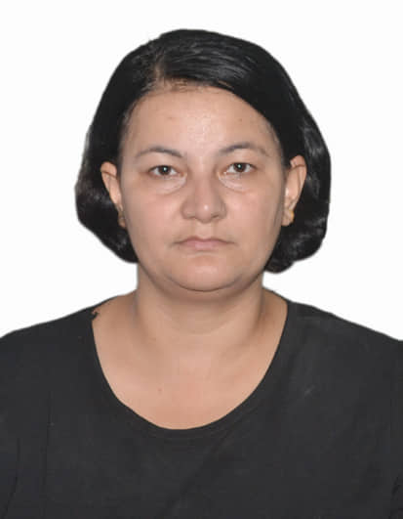
NAME: SRIJANA SHARMA
Father’s Name: Mr. Devi Prasad Sharma
Mother’s Name: Mrs. Tulasha Sharma
Permanent Address : NH 31 Jatiya Sarak, Shivmandir,
N.B.U, P.S- Matigara, Ranidanga,
Dist- Darjeeling, West Bengal, Pin – 734011
Date of Birth: 3rd June 1982 A.D.
Sex: Female
Marital status: Single
Ph. No : 0091 80525 88157, e-mail: srijanasharma09@gmail.com

Area of Research Work in Ph.D. is Nepali Fiction, specialization on Feminist Perspective and Nepali Writer Parijat.

ACADEMICS
- Ph.D. – Completed in 2017, Department of Indian Languages, Nepali Section, Faculty of Arts, Banaras Hindu University, Varanasi, India.
- UGC – NET ( Jan 2017)
- Post-Graduation: Completed M.A. in Nepali from North Bengal University in the year 2006
- Graduation: Completed B.A. (Honors In Nepali, along with History, Geography, Environmental studies, MIL Nepali, Compulsory English) from North Bengal University in the year 2004
- AISSCE (10+2): Completed Higher Secondary (Nepali Elective, English Core, History, Geography, Political Science) under CBSE Board in the year 2001
- AISSE (10th standard): Completed Secondary (English, Nepali, Social Science, Science, Mathematics) under CBSE Board in the year 1999

FELLOWSHIP: 1) UGC Research Eligibility Test (RET), (2012-2016),
2) National Eligibility Test in Nepali (2017)

AWARD: Parijat Samman- 2075 B.S. by Parijat Smriti Kendra, Kathmandu.

PERSONAL ACHIEVEMENTS
PAPER PUBLISHED: 17 (06 National and 11 International Journals)
BOOKS EDITED – 3
CONFERENCE & SEMINAR ATTENDED: 30
WORKSHOP ATTENDED: 10 (Including 2 Research Methodologies in Area Studies)
INTERACTION PROGRAM FOR Ph.D. SCHOLARS – 1
ORIENTATION COURSE IN WOMEN STUDIES: 1
REGIONAL SYMPOSIUM ON NLP: 1
SPECIAL LECTURES DELIVERED – 5
Workshop Attended on Translation – 1
Translated books – 4

PROFESSIONAL EXPERIENCE:
- At present, working as a Guest Lecturer in the Department of Nepali, North Eastern Regional Language Centre, Beltola Guwahati and experienced as a 2nd Language teaching Faculty.
- Experienced as a Guest Faculty in the Department of Nepali, Sikkim University for the Even Semester (i.e. 21st Feb, 2019 to 30th June 2019)
- Experienced as a Lecturer (Ph.D. Research Scholar) and taken classes in U.G. & P.G. Level in the Department of Indian Languages, Banaras Hindu University, Varanasi, India, (1st January 2013 to 31st August 2017).
- Experienced as a Technical Consultant in BRIHAD NEPALI SABDAKOSH and PRAGYA NEPALI–ENGLISH DICTIONARY project of Nepal Academy, Nepal, (1st June 2011 to 10th November 2012).
- Experienced as a Project Assistant in the DIT PROJECT, Development of Major North Eastern Languages-Nepali in Department of Nepali, University of North Bengal, (24th July 2008 to 05th May 2011).
- Experienced as a Volunteer Assistant teacher in Nepali High School, Naxalbari, (July 2006 to Dec 2006.)
IT SKILLS:
- Basic Computer Knowledge with DTP & CICE (Certificate in Computer Education).
- Is Familiar with Nepali typing in both Unicode and Legacy fonts.
- Can use linguistic tools like Toolbox.
- Can handle IPA typing efficiently.

COMMUNICATION SKILLS:
- Can Speak, Read and Write Nepali, English, & Hindi
- Can Speak Nepali, English, Hindi, Bengali and Bhojpuri.

AREA OF INTEREST AND EXPERTISE
Translation, Editing, Journalism, Linguistic Consultancy, Parijat, Nepali Literature And Language, Indian Nepali Fiction, Women Discourse, Nepali Fiction And Feminism, Child Rights, Human Rights and Road Safety.

Place: Guwahati Signature
Date: 15th February, 2020

