SOMDATTA NANDI

Linguist, Translator, Researcher, Academic content writer

Education

M.A in Linguistics, Jawaharlal Nehru University, New Delhi (2016-2018)

B.A. (Hons) in Linguistics, Sanskrit College, University of Calcutta, Kolkata
(2013-2016)

Experience
November 2018 – Present: Working as a content developer cum editor at Bitblits Digital Workstation
Worked as a freelance translator and academic content writer since 2015.

Research Experience and Personal projects:
1. A Socio-phonetic Study of Schwa-Fronting in two varieties of Hindi
2. A Field Report on Rajbanshi Language: A Survey in Compounding and Compound Words
3. No English Policy in the Age of Globalization of English: A Case Study in West Bengal
4. Language in the Time of Social Media: A Study in Bangla

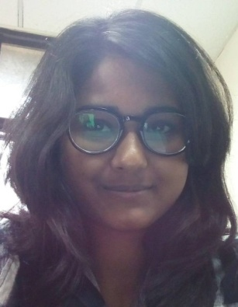

Address 140, Desh Bandhu Nagar
Po & District: Jalpaiguri
West Bengal 735101

Phone 9870229692

E-mail somdattan93@gmail.com

Date of birth 1993-09-20

Languages Bengali (Native speaker)

English

Hindi

Skills Academic writing

Translation Bengali>English

Translation English>Bengali

Research projects: Social science and Humanities

Subtitling

Software MS Word

MS Excel

MS Powerpoint

Praat (for phonetic analysis)

