CURRICULUM VITAE

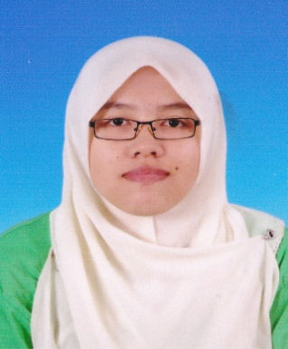

Siti Munirah Binti Abdul Malik
nyrahsiti@gmail.com
Mobile No: +60194762978 (Malaysia)

ACADEMIC QUALIFICATIONS

2011- 2012 : Matriculation (Science)
Kolej MARA Kulim, Malaysia

2012 - 2016 : Bachelor of Education in Information Technology (Present)
Sultan Idris University of Education, Malaysia

ACADEMIC CERTIFICATE

2009 : German International Language Certificate
2010 : Education Certificate of Malaysia
2012 : Malaysia University English Test (MUET)
2012 : Certificate of Matriculation

WORK EXPERIENCE

Freelance Work:

2012 :
July - Virtual assistant for ongoing projects
- Data entry
- Web scraping

September - English-Malay documents translation for ongoing projects
- English-Malay website translation

November - English-Malay Health website translation
- German-Malay small translation

2013 :
March - English-Malay powerpoint translation

Jun - English-Malay website translation
- English-Malay web-based application translation
- English-Indonesia web-based application translation

July - Data entry
- English-Malay powerpoint translation

August - Malay audio transcription

Oktober - English-Malay Nordex Trading website proofreading
- Copy typing
- English-Malay document translation
- English-Malay financial translation and document proofreading

November - English-Malay powerpoint translation
- English-Malay Android application translation
- English-Malay Health Science articles translation/proofreading(ongoing)
- English-Malay Iphone application translation(contract)

December - Medical English-Malay translation and proofreading (present)

2014:

January - Lenovo English-Malay mobile application translation
- Medical Eng-Malay proofreading
- English e-learning course

March - Translation of Islamic app
April - Blog translation
- Website translation
June - Translation Eng-Malay of Rally Game application
- Proofread email response and shipping terms

ABOUT ME
Professional & thorough; skillful & passionate; attentive to meaning and style. Deliver a high quality works with lower prices. An independent translator and proofreader.Expertise in Science, Health Science, Mathematics, Technology, Computer Science, Software, Common Sense and Social Networks. Able to handle all the words and terms of these fields. Actually anything even the sensitive issues, LGBT. Translation of a creative or even of daily language cannot be done literally. The nuances of the target language should be incorporated as to produce a nice flowing prose. I will do some research to ensure the accuracy and get some helps from others to proofread my works. I love the challenge and the need of perfect listen and research skills to deliver a high-quality works. I have more than one year experiences in the freelance world. I enjoyed being a translator, proofreader, virtual assistant and do other simple tasks. Here is a simple CV of mine as I am a student and only deliver my services online.

