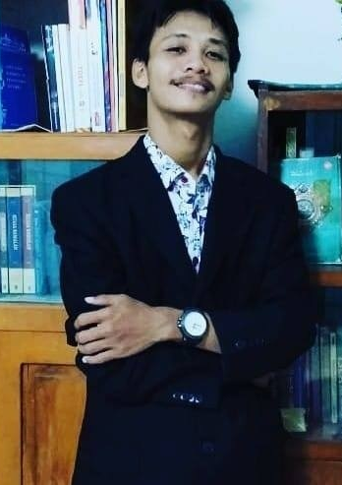
SIGIT MUKTI NUGROHO

PERSONAL INFORMATION
NICKNAME (ALIAS) | : | SIGIT
ADDRESS | : | MLATI KIDUL GANG NYAI DASIMAH NO. 6 RT 5/1 KUDUS, CENTRAL JAVA 59319  INDONESIA
EMAIL | : | seagate.balaboners@gmail.com
PHONE | : | +62 85 700 591 470
GENDER | : | MALE
PLACE OF BIRTH | : | KUDUS
DATE OF BIRTH | : | 3 FEBRUARY 1991
BLOOD GROUP | : | B
HEIGHT/WEIGHT | : | 165 CM/50 KG
RELIGION | : | ISLAM
NATIONALITY | : | INDONESIA
MARITAL STATUS | : | MARRIED

FORMAL EDUCATION
PERIOD | LEVEL | INSTITUTION | FACULTY/PROGRAMME
1997 – 2003 | PRIMARY | SD 1 MLATI KIDUL KUDUS
2003 – 2006 | SECONDARY | SMP 1 KUDUS
2006 – 2009 | POST-SECONDARY | SMA 1 GEBOG KUDUS | LANGUAGE PROGRAMME
2009 – 2013 | UNDERGRADUATE  (HIGHER EDUCATION) | UNIVERSITAS MURIA KUDUS | TEACHER TRAINING AND EDUCATION FACULTY  ENGLISH EDUCATION DEPARTMENT
Final Project (Skripsi) Title: An Analysis of Modality in the Script of Anthony Robbins’ Motivational Speech “Why We Do What We Do”

INFORMAL EDUCATION/TRAINING
YEAR | PROGRAM | INSTITUTION
2010 | SMART GENERAL ENGLISH | PRIMAGAMA ENGLISH KUDUS
2019 | DRIVING | EMC INFORMATIKA KUDUS

ORGANISATIONAL EXPERIENCES
YEAR/PERIOD | ORGANISATIONAL POSITION
2009 – 2012 | Member and Board of English Student Association (ESA)  University of Muria Kudus (UMK)
2010 | Committee of English Grand Season Competition held by ESA UMK
2011 | Chief of Committee of English Family Camp for English Student Association  University of Muria Kudus
2011 – 2012 | Member of ICT Department of English Student Association  University of Muria Kudus
2012 | Chief of Committee of Training ‘Revolusi Pengajaran dengan NLP’ (Teaching Revolution with NLP)

VOLUNTEERING EXPERIENCE
PERIOD | POSITION | INSTITUTION
2017 – 2018 | Administration staff | Nurul Jannah Orphanage

PART-TIME JOB EXPERIENCES
YEAR/PERIOD | POSITION AND INSTITUTION | DESCRIPTION
2012 – present | Independent Translator  EL MEDINA TRANSLATION  (My own translation service) | I started translation services in 2012 and help people translate their abstracts, academic articles, book chapters, etc.
2011 – 2012 | English Tutor  BIMBEL ANNUR (COURSE) | I taught English subjects at one of private courses in Kudus.
2012 – 2014 | English Instructor  SPEAK UP! ENGLISH COURSE | I taught English speaking to students of primary and secondary schools as one of the representing teachers of the English Course.
2014 | Assistant to Lecturer  MIDWIFERY ACADEMY, KUDUS | I assisted my former lecturer to teach midwifery students about English for Midwifery for one-semester length period.
2015 – 2016 | English Instructor  ENGLISH EXTRACURRICULAR ACTIVITY – MTs N 1 KUDUS | I taught English during extracurricular activity to help students of MTsN 1 Kudus improve their English scores in morning classes.
2015 – 2016, 2019 | Private English Teacher | At home, I also teach English to students who need more English learning.
2018 – 2019 | Blog content writer | I created the contents by writing articles on Mesothelioma based on various online articles. Cooperating with a friend who is a web designer, our project ended up unfinished. Then I compiled all the articles into an e-book. I propose it to amazon.com and it was accepted to be one of the Amazon Kindle Products.
2019 – present | English Tentor  PT ENORMOUS INDONESIA - PKN STAN COURSE | I teach English at a course in ENS (ENORMOUS) course, to prepare students to face admission test at State College of Accountancy (STAN).
October – Desember 2019 | (Substitute) English teacher  MTsN 1 Kudus | I was assigned a job as a substitute English teacher at MTsN 1 Kudus from October until the end of odd semester academic year 2019/2020.

PUBLICATION
TITLE | YEAR | PUBLISHER | DESCRIPTION
A Short Story – “Tertinggal” in a anthology of short stories by FKIP UMK students “CURHAT” | 2011 | INDIE PUBLISHING | A self-funding publication with all authors of the book.
CARA CESPLENG PINTAR BAHASA INGGRIS SMP | 2015 | ANDI PUBLISHER YOGYAKARTA | I was one of the co-authors to write this English subject book.
CARA CESPLENG PINTAR BAHASA INGGRIS SMA | 2015 | ANDI PUBLISHER YOGYAKARTA | I was one of the co-authors to write this English subject book.
Mesothelioma 101: A Simple Guiding Self-Help to Conquer Mesothelioma | 2019 | Amazon Kindle Publishing  (amazon.com) | Initially, it was a web-creating project. I rewrote articles on mesothelioma from various related websites and published them on web. At the end, the project was not accomplished, and then I decided to publish them through Amazon on  www.amazon.com/MESOTHELIOMA-101-Guiding-Self-Help-Mesothelioma/dp/1075686121

Herby, I declare that all statements in this resume are valid and accurate. This is the end of my resume.

Sincerely yours,
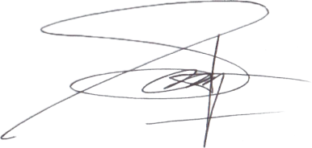

Sigit Mukti Nugroho

