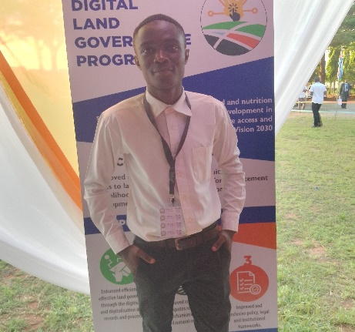
SHARIFF ANYANGA AMBANI.
FOUNDER AND CEO PREMET TRANSLATORS
Tell: +254 790637910.
Email: translatorshariffambani@gmail.com
ambanishariff@gmail.com.
LANGUAGES
Swahili: Native
English: Proficient
Arabic: Proficient
French: Intermediate
PROFILE
Enthusiastic individual with extensive language and linguistics knowledge. Adapts quickly to online tools and platforms. Demonstrates keen cultural awareness and interpersonal skills. A flexible leader with a positive mindset that helps in dealing with arising situations. A customer focused person, successfully contributing to company profits by improving team efficiency and productivity. Skilled at effective negotiations and upselling techniques. Utilizes excellent organizational skills to enhance efficiency and lead teams to achieve outstanding results.
ACCOMPLISHMENTS
- Founder and CEO PREMET Translators
- Underwent translation training from a seasoned translator Alfred Mtawali who is the head of East Africa Association of Interpreters and translators and CEO CAN TRANSLATORS NAIROBI.
- Worked directly with senior leadership at CAN TRANSLATORS to develop and administer the best Language Services to Clients.
- Member of East African Translators and Interpreters Association.
- Built and nurtured key client relationships to grow profits at CAN TRANSLATORS.
- A certified Data Protection Officer and Internet Governor.
WORK EXPERIENCE
1STSEPTEMBER TO DATE: PREMET TRANSLATORS
- Senior Translator, Interpreter, Proofreader, Editor and Transcriber for English to Swahili or vice versa. CAT TOOLS I use (MemoQ, TRADOS STUDIO, WORDFAST, Memosource, etc.)
- Making major decisions at the Language Agency.
- Managing overall operations at the Agency like Assigning Language Works to concerned Language Experts and Linguists.
- Marketing of the Language Agency in various platforms.
APRIL TO SEPTEMBER 2023: CAN TRANSLATORS NAIROBI
TRANSLATION
- A Swahili-English /English-Swahili freelance translator Covering various topics including Medical documents, Financial documents, legal documents, Brochures, etc. and samples can be sent upon request.
INTERPRETATION
- A Swahili-English/English-Swahili freelance Interpreter during various meetings hosted by various people.
TRANSCRIPTION
- Transcribed various Audio files and Video files to Word Documents and later Translated them to English and or Swahili
PROOFREADING
- Proofreading documents either translated by us or by other translators upon request for proofreading by the clients.
EDITING
- Edited various documents like short stories, novels, narratives, poetry, songs etc.
OTHER ACTIVITIES
- Maintained focus under pressure to deliver accurate Language Services.
- Proofread documents to remedy terminology and vocabulary errors.
- Obtained information on appropriate terms, phrases and words from specialist dictionaries.
- Adapted existing translations to meet style guidelines.
- Consulted with specialists to obtain information on technical information translation.

FEBRUARY TO APRIL 2023: MOZILLA FOUNDATION
- A participant in the writing of compositions and addition of enough content of Kiswahili words on the commonvoice.mozilla.org/sw website under ‘’Sauti Ya Jamii” initiative.
AUGUST 2022: IEBC KENYA
- Conducted the Kenya General elections as a polling and counting clerk

SEPTEMBER 2019-2023: PWANI UNIVERSITY
- A student Translator and Interpreter.
- A student proof-reader.
- A student researcher.

EDUCATION

1ST JULY TO OCTOBER 2023: INTERNATIONAL YOUTH FELLOWSHIP WEEKEND ACADEMY KENYA
- Studying French Language together with Mindset and or Leadership Education.
JULY TO AUGUST 2023: WEBBIIT TECHNOLOGIES ONLINE AGENCY
- Web Design and Web Development Training.
JUNE 2023 TO DATE: DEEN KHALIS ONLINE ISLAMIC ARABI ACADEMY NAIROBI
- Intensive Arabic Language Studies.

2ND to 22ND June 2023: KENYA SCHOOL OF INTERNET GOVERNANCE
- Pursue Internet Governance studies courtesy of KICTANet.
SEPTEMBER 2019- APRIL 2023: PWANI UNIVERSITY KILIFI KENYA.
- Bachelor's Degree of Arts in African Language (Kiswahili), Linguistics and Literature together with communication.
- Graduate
- Academic Achievement Award
- Area of Expertise (Translation, Communications, Journalism and Creative Writing)
MAY-AUGUST 2019: EARTHRISE INSTITUTE OF TECHNOLOGY NAIVASHA KENYA
- Pursuing Computer studies.
2015-2018: ST. PETER'S BUCHIFI HIGH SCHOOL KENYA
- Pursuing Secondary School Education
- Academic Achievement Award (C+Plus)
2007- 2014: IHONJE PRIMARY SCHOOL KENYA.
- Pursuing primary school education (320 Marks).
2005- 2007: IHONJE KINDERGARTEN SCHOOL
- Early childhood education.
SKILLS
- Translation and Interpretation skills
- Proofreading skills
- Research skills
- Live Translations
- Written Translations
- Real-Time Translation
- CAT Tools
- Community Interpreting
- Language Skills
- Communication skills
- Creativity and Innovativeness
- Problem solving skills
- Risk management skills
- Continuous learning skills
- Leadership skills
- Public policy skills
- Capacity building skill
HOBIES
- Reading Books
- Watching Documentaries and movies
- Watching Latest News
- Engage in Discussions
REFERENCES
DR. NANCY NGOWA MR. ALFRED MTAWALI
C.O.D LANGUAGES LITERATURE AND LINGUISTICS. CEO CAN TRANSLATORS NAIROBI.
SCHOOL OF HUMANITIES AND SOCIAL SCIENCES. ADRESS:35148-00100, NAIROBI.
PWANI UNIVERSITY KENYA. TEL: +254722304178.
ADDRESS: 195-80108 KILIFI KENYA. EMAIL: info@cantranslators.com
TEL: +254723750159.

DR. VIOLET AURA
SENIOR LECTURER
DEPARTMENT OF LINGUISTICS
PWANI UNIVERSITY
Tel: +254722263841

