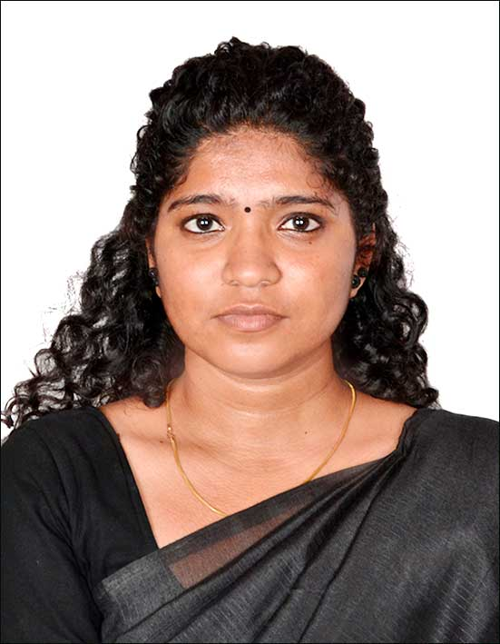
S.SHALINI,
Selliyayeepalayam,
Kalangani(PO),
Namakkal(TK)(DT).
Cell: 9488541883
Mail: shalumathi0512@gmail.com

Summary
Dedicated and motivated arts graduate with good teaching skill, a hard worker with good language skill seeking for an opportunity to create a positive environment and promote self-esteem.
Highlights
- Public speaker
- Innovative thinker
- Inspiring lecturer
- Personable and approachable

Accomplishment

- Personality Development Course in Yoga for Human Excellency.
- Attended Infosys Training .
- Published a paper on “A Study of Magician Realism in Odiyan through the collective conscious of Paruthipulli” in IJELS in 2020.
- Published a paper on “Cultural Identity in the novel ‘A Girl with the Dragon Tattoo’ in an international online journal, IJELR in 2019
- Published a paper on “Exemplification of Gender Politics in Kathryn Stockett’s The Help” in IJELR in 2019
- Published a paper on “Fudgy Religion in Arvind Adiga’s The White Tiger” in an International Conference held on 2018 at Bharathiar University in Coimbatore.
- Published a paper on “A delibration on Compulsive Sexual Behaviour in Paula Hawkins’ The Girl on the Train” in 2018
- Published a paper on “Entrepreneurship in Arvind Adiga’s ‘The White Tiger’ in an International Conference held on 2012 at Muthayammal Memorial College of Arts and Science in Rasipuram.
- Presented several papers in International and National Conferences.
Experience
Assistant Professor 15/ May/2019- Current
Sri Krishna College of Arts and Science College Coimbatore
- Organized FDP on ‘Effective Communication Skills.’
- Placement Co-ordinator in Sri Krishna Adithya College of Arts and Science
- Gave vigorous training to slow learners.
- Prepared Press Report.
- Newsletter Co-ordinator
- Collected educational information and taught to students during classes.
- Conveyed subject matter and lecture to the students in a creative way.
- Ensured completion of assigned syllabus within the time-frame given.
Online Tutor/Personal Tutor 26/Jan/2019- 02/Mar/2019
Benatech Institute
Coimbatore.
- Evaluated the student individually to identify areas of difficulties
- Personal care was given to uplift his enrich the student’s communication skill.

Education
- Post Graduation-Bharathiar University
Coimbatore
- Under Graduation-Muthayammal Memorial College of Arts of Arts and Science, Rasipuram
- 12th- Little Angels Hr. Sec. School,
Namakkal
- 10th – Sri Vani Matriculation Hr. Sec School
Namakkal

