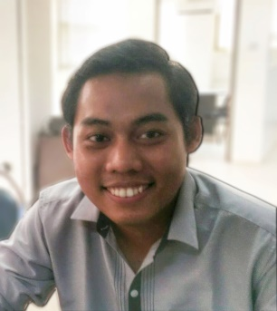
Mr. Saw Minthu Oo
Freelance Content Developer
Email : minthuoo84@gmail.com
Phone : 09799649606
LinkedIn : www.linkedin.com/in/sminthuoo

About me

Since my return to my country in 2014, I have been much interested in content development for websites and social media. Although my formal qualification is health, because of strong desire, I studied and gave much time to study online marketing fundamentals, web development and content management, translation of articles to Myanmar and do research online for articles to add in my websites and social media. To highlight some of my works as content developer, I write articles on www.entrepreneurs-mm.com and www.facebook.com/myanmaentrepreneurs. Also I translate product documents into Myanmar as a freelance translator for consumer electronic products and INGOs.

Personal Identification

Name - Mr. Saw Minthu Oo
Nationality - Myanmar
Date of Birth - 27 December 1984
Gender - Male
Address - No. 62, 5F (B), Wakema Street, Sanchaung Township, Yangon
Website - www.entrepreneurs-mm.com

Work Experiences

Freelance Content Developer  2014 – till now | - Administer www.entrepreneurs-mm.com and Entrepreneurs in Myanmar Facebook Page (www.facebook.com/myanmaentrepreneurs)  - Develop interesting contents (writing, designing and communicating with audiences)  - Conduct content research on internet and write articles  - Translation & transcription from English to Myanmar language (articles, consumer products, case study, etc.)  - Create logo designs and graphic images for web
Managerial positions in INGO  2008 – till now | - Project management for donor funded projects  - Report writing in English  - Develop training curriculum and conducts training to different audience  - Participate in research  - Organize workshop, seminar, etc.  - Conduct talk to audience about community development and health promotion
Education

Certificate in Small and Medium sized Enterprise Development  July - December 2014 | KV Zurich in affiliation with Myanmar Business Executive  Courses  - General Management  - Financial Accounting  - Human Resources Management  - SME Development
Master of Science (Public Health)  2013 - 2014 | Umea University, Sweden  Courses  - Global Health  - Research Methodology (Qualitative & Quantitative)  - Health Economics  - Health Systems Financing  - Statistics
MBBS  2001 - 2007 | University of Medicine 2, Yangon

Computer literacy
- Burmese typing
- Microsoft Word, Excel, PowerPoint and OneNote
- Adobe Photoshop, flash, Dreamweaver
- Web Development (HTML, CSS, JavaScript, PHP, MySQL)
- CMS (WordPress)

Language Skills
- Burmese (Mother tongue)
- English (Proficient)

Scholarship Awarded
- Full scholarship to study SME development certificate course in Yangon by MBE, offered by KZ Zurich Business School in Switzerland, INEDUCO project (2014)
- Erling Person Family Foundation Scholarship to study Master Degree in Umea University, Sweden (2013)
- SEAMEO REFCON scholarship to study postgraduate course on Health Systems Analysis in University of Indonesia, Jakarta, Indonesia (2011)
- United State Embassy scholarship to study Community Development online course offered by Colorado State University, Village Earth program (2011)

