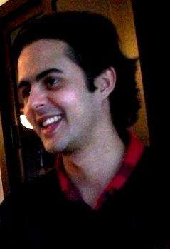
Calle 66B # Cir 1 – 13, Bolivariana, Medellín – Colombia.
Colombian. santiagobustag@gmail.com. (+57) 3003456677
Blog: santibusta.blogspot.com/

Santiago Bustamante González
BA in Humanities and Spanish Language. 30 years.

Professional profile | - Over 10 years of experience in the translation sector  - Career path between Colombia, Germany, Hungary and the United Kingdom  - Approaches: editorial management, education and fiction writing  - Extensive experience in linguistics and literature
English  German | Speaking  Writing  Listening  Reading  Speaking  Writing  Listening  Reading
Experience | freelancer 2007 – Present  Independent  Impact: Writer/Translator/Proofreader/Transcriber/Content Manager  Universidad de antioquia Medellín. 2014 –2015  University teacher  Impact: Research and teaching position. Comics theory and practice  editorial gotama. medellín April 2013 – May2015  Director  Impact: To provide translation and web content services for a diversity of industries.  langwest language school. hungary 2011 –2013  English, German, and Spanish teacher  Impact: Language teaching position.  content manager 2010 –2011  Verdeate.com  Impact: To provide and manage web content  one medellín S.A.S. April 2010 – October 2010  Editor in chief  Impact: Content creation and public relationships  omni facilities plc. 2006 – 2007  Housekeeping  Impact: Customer Service in Melia White House. Tourism and Housekeeping. English Spanish interpretation for guests
Education | Universidad de antioquia. 2016  BA in Humanities and Spanish Language.  hEINRICH HEINE UNIVERSITÄT 2010  German as a foreign language (DaF)  UNIVERSITÄT LEIPZIG 2012  Translation and interpretation
Publications | Universo Centro no. 43 – Cuadros Magiares: Budapest. Periódico Nexos de EAFIT – Humanos Demasiado Humanos, Del Sexo y Otros Placeres Industrializados, Cuerpo y Consciencia 2045, and El Arte Secuencial. Periódico Generación de El Colombiano, Serás un Rey Magiar, 28 de septiembre 2014. La falsificación y la imitación en el proceso creativo, por Glenn Gould. Revista Universidad de Antioquia no. 322, Oct-dic 2015.
Research | COMICS IN THE HIGHER EDUCATION

