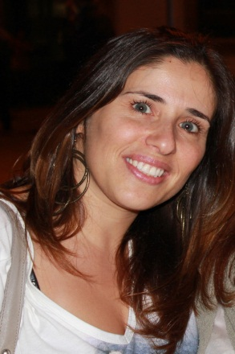
Ferreira sandra

e-mail: scrf29@hotmail.com
Cellphone: 00351962513397/
234 343 687
Languages: English/Spanish/French
Interesses: Fotography; Makeup

diploma languages and editorial studies
professional experience

2013
Private English lessons
English-Portuguese and Spanish-Portuguese Translations
English trainee Comercial Techniques

diplomas/certificates

2013 English Commercial Services Techniques
2012 Forinova (Trainer)
2007-2011Bachelor’s Degree at the University of Aveiro
1999 High School Dr. Mário Sacramento

[Fax] • [Email]
[Street Address] • [City, ST ZIP Code] • [Phone]

