CURRICULAM VITAE
PERSONAL INFORMATION
NAME : SAIKAT DUTTA
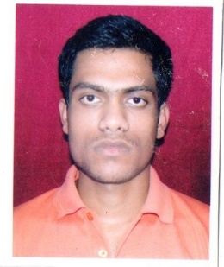
FATHER’S NAME :KUSUM KUMAR DUTTA
MOTHER’S NAME :NAMITA DUTTA
DOB :13/03/1996
MARITAL STATAS :SINGLE
SEX :MALE
NATIONALITY :INDIAN
RELIGION :HINDU
ADDRESS :SODEPUR,VILL-MILANGARH,P.O-NATAGARH,KOL-700113

CARRER OBJECTS
MY DESIRE TO WORK IN A WORKPLACE WHERE I CAN ACCURATELY REPRESENT MY TALENT AND SKILL.

EDUCATIONAL QUALIFICATION (ACADEMIC)
STANDARD | MARKS | YEAR | BOARD | INSTITUTE
MADHAMICK | 469 | 2012 | WBBSE | SODEPUR HIGH SCHOOL
H.S | 207 | 2014 | WBBHSE | AGAEPARA MAHAJATI VIDYAPITH
(TECHNICAL)
STANDARD | STREAM | YEAR | BOARD | INSTITUTE
I.T.I | AUTOMOBILE | 2015-17 | NCVT | GOVT. ITI GARIAHAT

WORKING EXPRENCE
- 7 MONTH WORKING EXPRENCE ON HONDA MOTORCYCLE PLANT, GUJRAT AS A CONTRACTUAL.
- 2 YEAR WORK EXPRENCE AT UNIVERSAL TVS SERVICE CENTER ON SPARE PARTS DEPERTMENT.

SKILLS AND CERTIFICATE
- CERTIFICATE ON THE FUNDAMENTAL OF DIGITAL MARKETING COURSE BY
GOOGLE DIGITAL UNLOCKED.

- CERTIFICATE OF INFORMATION TECHNOLOGY APPLICATION.(DITA) IN YOUTH
COUMPUTER TRAINING CENTRE.

- DRIVING LICENSE IN 4 WHEELER.

LANGUAGE KNOWN AND HOBBIES
- BENGALI , HINDI , ENGLISH. 2. INTEREST IN SPORTS AND READING BOOKS.

REFERENCE
- PHONE NO . ---- +91 9433017325 , EMAIL ID ---- effectbubun@gmail.com

