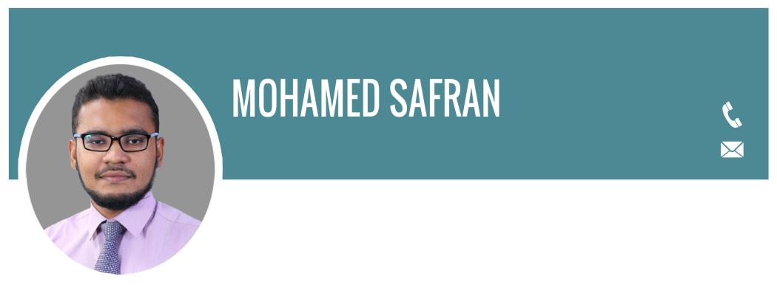
+94 77 60 32 629
safranmohamed23@gmail.com
Date of Birth: 21.06.1990
Place : Weligama
Gender : Male
Civil Status: Married

Name in full: Mohamed Mohamed Safran
Name with initials: M.M.Safran
Credentials:
Proz : https://www.proz.com/profile/2430365
Translatorscafe:
https://www.translatorscafe.com/cafe/member333967.htm

Bachelor of Science in Civil Engineering, Faculty of Engineering, University of Ruhuna, Sri Lanka. Course completed on January 2015

Degree Courses
EDUCATIONAL QUALIFICATION
- Structural and building Materials
- Water and Environmental Engineering
- Hydraulic Engineering
- Geotechnical and Geo-environmental
- Surveying and Transportation Engineering
- Infrastructure planning and Management

Expo Development Foundation
2016| Certificate of Technical writing and presentation skill | 1 year study
TRAINING

Peradeniya University of Sri Lanka
2015| Certificate of General Proficiency in English | 1 year study

Executive, Linguist and Consultant
EXPERIENCE
Freelance| 75/31 Madurapura, Denipitiya 81730, Sri Lanka | November 2011 – Present
- Management consulting, business reporting, business & marketing analysis, commercial negotiations
- Cross checking, editing, interpreting, proofreading, rewriting, software localization, subtitling, trans- creation, transcription, translation, linguistic validation and website localization
- Teaching and training of language and communication

Chief Site Engineer
Sumitomo Mitsui Construction Co. | November 2017-Present
- Check and review the plans and specifications for the proper construction and quality implementation at job site.
- Leveling.
- Concrete Inspection.
- Sub Grade and Sub base preparation inspection.
- Checking formwork and reinforcement of culvert structures, drainages etc.
- Coordination with technical officer for any change in drawings or any revision and QA/QC department.
- Site management and handling the work as per specification and drawings and method of statements.
- Proper management of materials and workmanship.
- Making daily report and reporting to Construction Manager.

KEY STRENGTHS AND SKILLS
- Fluent in 3 national languages (Sinhala, Tamil and English).
- Good knowledge in computer software (Engineering related software, MS Project, Primavera P6 and commonly used packages).
- Working fast and changing myself to new technologies.
- Good communication skill with any kind of people.
- Good in problem solving, decision making and creative thinking

LANGUAGES
- English, Sinhala and Tamil- Speak fluently and read/write with high proficiency
- Tamil | First language and 13 years of both education and instruction
- Sinhala | 11 years of education and presently use in the site
- English | 14 years of education

I hereby certify that the above particular details are true and correct to the best of my knowledge.

M.M.Safran

