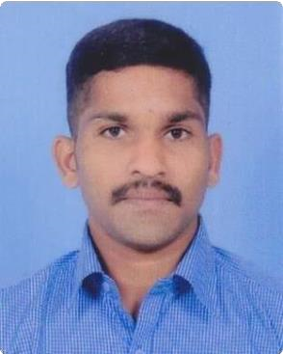
ROBIN KORAH
Email: robinkorah68@gmail.com

LinkedIn: https://www.linkedin.com/in/robin-korah-7a7102106?trk=contact-info
Fiverr Gig: https://www.fiverr.com/s/9AxzVa
Phone : +91 9074677168
Address: Thakidiyil (H), S.N. Puram p.o , Pampady , Kottayam-686502 Kerala, India

Work experience
G Tech Computer Education
Current job title : Data entry specialist, G-Tech Computer Education , Kottayam - 2020 July to Present.
More than 1 years experience in proofreading and translation (G Tech Computer Education).

Impulse Marketing Pvt ltd
Business development executive DEC 2014-FEB 2017,
3 years experience in Marketing Books and School Software’s.

Education
B.Sc. Physics
St.Marys college Manarcaud , Kottayam (2007 – 2010)

VHSE in Rubber Technology
Govt VHSS Kothala (2005 – 2007)

SSLC
Govt VHSS Kothala (1995 – 2005) .

Language skills
- English
- Malayalam
- Telugu
- Hindi
- Tamil
- Chinese Mandarin
- Foreign Languages : Spanish, French & German language Certificate ( 1 year part time course: Traum Academy for German, French, Kochi): 2019
- Arabic language certificate (6 month course): Arabnet Academy (Translation – Authorized Center), Kozhikode: 2017

Certificates
- Graduate in B.Sc. Physics with 64.41%marks (2007-2010)
- VHSE in Rubber Technology with 67%.(2005-2007)
- SSLC with 63%.(1995- 2005)

Other Certificates
- Certificate in MS Office
- NCC Army wing C certificate (16Kerala battalion NCC Kottayam
- All India trekking expedition Marayoor, Idukki district.

Personal details
Nationality : Indian
Date of birth : 24/02/1990
Martial Status : Unmarried

Declaration
I do hereby declare that all the above information’s and statements are true and correct to the best of my knowledge and belief.
ROBIN KORAH.
Place:Pampady
Date:

