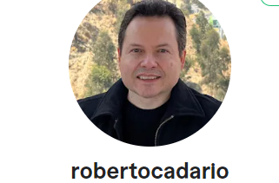

NAME : ROBERTO CADARIO EL HAGE

I am from Bolivia with an Economic major and MBA. I have experience in translating documents English-Spanish and Spanish-English, as well as making data entry and transcription requirements. I went to College in the United States and have lived in the US for 5 years. I have also lived in Brazil and a have a conversational level of portuguese.

Education:

- MIAMI DADE COMMUNITY COLLEGE.

United States,Graduated 1992.

- FLORIDA INTERNATIONAL UNIVERSITY

United States, Graduated 1994

Languages:

- English - Fluent
- Spanish (español) - Fluent
- Portuguese (Português) - Conversational

