Resumé
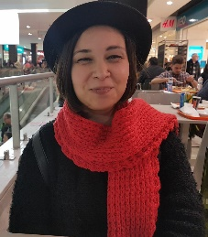
Rita Sofia Hora Bernardo da Rocha Grave
Contacts:
e-mail: rita.rocha.translationrocks@gmail.com
telephone number: ++351914779953
Ø Personal information:
Nationality: Portuguese.
Date of birth: 17/01/1990

Ø Academic Qualifications:
2017: Spot translation course at Willzilla.
2012 to 2014: Master’s Degree in Legal Translation at the University of Aveiro.
2009 to 2012: Translation Studies Degree with specialization in English and German. University of Aveiro. Portugal.
Subjects studied include: | Theory and Methodology of Translation
 | Terminology
 | Latin
 | Germanic Literature
 | German translation practice
 | English translation practice
 | Technologies that support translation
From 2007 to 2009- Escola Secundária Dr. João Carlos Celestino Gomes. (Humanities Area
Ø Language Skills:
Languages | Comprehension | Speaking |  |  | Writing
 | Reading | Speaking | Interacting | Producing | Written production
English | C1 | C1 | C1 | C1 | C1
French | B2 | C1 | B2 | B2 | B1
German | B2 | B2 | B2 | B2 | B2
Japanese  Italian | B2  C2 | B2  B2 | A2  B2 | A2  B2 | A2  B2
Spanish | C1 | A2 | A2 | A2 | A2
Ø Professional Experience:
March 2014 to September 2016- Project Manager at Tradu24.
October 2013 to January 2014- Internship at the "Museu Marítimo de Ílhavo"- (Codfish Museum in Ílhavo-Portugal).
September to October- Internship at the "Fórum da Juventude"- (Management of teen activities).
June 2013 to January 2014- Kindergarden teacher at the Colégio de Calvão.
June to July 2013- Translation and subtitling at FEST- Festival Internacional de Cinema de Espinho.
June to July 2012- Translation and subtitling at FEST- Festival Internacional de Cinema de Espinho.
September 2012 to present- freelance translator.
March 2014 to September 2016
Ø Project Manager, Tradu 24
Responsibilities: Manage translation projects (translation and proofreading), create quotes, issue invoices, follow-up client’s quotes and projects. Be punctual and active at work. Interact with both clients and translators.
Competences:
Ø Competences acquired and developed: I learn how to handle the clients,
to be responsible, to work shifts, and to work under pressure.

Ø Skills Profile: Due to my previous work experience I’m able to listen to the client’s needs and to work under pressure. I’m also able to work in shifts,
Ø Skills profile: I’m responsible, hardworking and committed.
One of my weaknesses is being perfectionist. Although I’m perfectionist, because I analyze my work so carefully, my work tends to have a high standard.
June 2012 to present
Ø Freelance translator
Responsibilities: Translate, proofread and subtitle legal, technical, medical and pharmaceutical documents, clinical trials, video-games, gambling websites and apps, cooking and recipe books, marketing and educational documents, surveys and questionnaires, literary documents and books, tourism websites, travel guides, hotel and spa brochures, translation of sports materials and beauty products.
Subtitle movies and TV series for FEST and companies working for Netflix.
Competences:
Ø Competences acquired and developed: Specialized translation in legal and technical translation.
Advance knowledge of Netflix guidelines.
Proficiency working with Spot 6, Aegisub and Subtitle Workshop.
Ø Skills Profile: Responsible, accurate and precise translation work.
Ø Some of my clients:
Samsung Siemens Sony Hilton Hotel Santander Totta
Netflix
Ø ICT: Windows Office( Microssoft Word; Excell; Power Point.)
- Translation software:
SDL Trados Studio 2015 Freelance
MemoQ
Wordbee
Transit NTX
- Subtitling software:

Spot 6

Aegisub

Subtitle Workshop
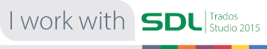
Ø Relevant membership association:
APT (Portuguese Association for translators)
APPortugal
Lexis
Subtle – professional subtitle association
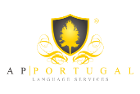
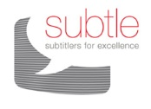

Ø Other relevant information:
Ø I was part of the church’s choir at primary school.
Ø I won a literature contest at primary school.
Ø I was part of the schools newspaper team (writing articles and proof-reading)
Ø I also studied dance for 4 years (since ballet to contemporary dance).
As a freelance translator I worked for companies like Samsung, Sony, Hilton Hotel, Santander, Siemens, and several other companies.
January, 2018

