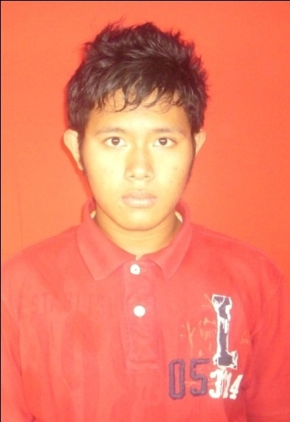**Curriculum Vitae**

**Personal Information**

Name : Rio Heryasta

Gender : Male

Date of Birth : Jakarta, March 11th, 1994

Nationality : Indonesia

Religion : Islam

Address : Jalan Tipar Cakung Kampung Baru RT 02/007 No.115

Phone Number : 089604711943

WA number (only) : 088809741144

BBM Pin : 57AF5D87

E-mail : [rio_heryasta@yahoo.co.id](mailto:rio_heryasta@yahoo.co.id)

**Educational Background**

**Formal**

2000-2006 : SDN 08 Cakung Barat Jakarta

2006-2009 : SMPN 144 Jakarta

2009-2012 : SMAN 76 Jakarta

2012-Now : S1 Pendidikan Bahasa Inggris Universitas Indraprasta PGRI

**Non-Formal and Seminar**

2009-2012 : Participated ‘Pembelajaran Teknologi Informasi dan Komunikasi’

July 4th, 2010 : Participated Jakarta Timur Taekwondo Championship

2010-2011 : Participated Bimbingan Belajar Program IPA Nurul Fikri

March 25th, 2011 : Participated LPIA-EPT (English Profiency Test)

March 10th, 2012 : Participated LPIA-EPT (English Proficiency Test)

July 04th, 2012 : Participated Jakarta Timur Taekwondo Championship

September 29th, 2012 : Participated Jakarta Timur Taekwondo Championship

March 02nd, 2013 : Attended Seminar Manage and Developing Game

March 31st ,- April 01st, 2013 : Attended LKM (Latihan Kepimpinan Mahasiswa) UNINDRA

May 18th, 2013 : Participated PORWIL Jakarta Timur Taekwondo Championship

June 04th, 2013 : Participated Seminar English as E-Learning

December 28th, 2013 : Participated seminar ‘Wirausaha Muda Menyongsong Masa Depan’

December 12th, 2014 : Participated seminar Hypno Teaching for Better Education

December 20th, 2014 : Participated seminar Microexpression and Body Language

March 21th – 23th 2015 : Attended LKM (Latihan Kepimpinan Mahasiswa) UNINDRA

**Working Experiences**

1. February - June 2015 : English Teacher, BIMBIKA

2. March – Now : English Teacher, Golden English

3. August – October 2015 : English Teacher, Balai Latihan Kerja Daerah (BLKD) North Jakarta

4. February 2016 : Freelance Translator for Mahasantri

**Personal Skills**

1.Sport : Taekwondo. (belt : red strip 1.)

2. Language : English (good in written and oral.)

**Organization Experience**

Januari 2004-Now : Taekwondo as member. Now as an assistant coach.

2009-2012 : SMAN 76 Jakarta choir group as member.

2009-2012 : ROHIS (Rohani Islam) SMAN 76 Jakarta as member.

2012-2013 : UNITAS (Unit Aktifitas Mahasiswa) UNINDRA as member.

This personal information is based on my true experience and my knowledge.

Sincerely yours,

Rio Heryasta