REKA HARSANYI
Mobile: +36 30 928 0038
Email: rekaha@mailbox.hu
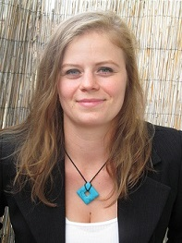

PROFILE
- Date of birth: 14. May 1989., Debrecen, Hungary
- Address: 4200, Hajdúszoboszló, Rákóczi utca 17. D ép. TT. 17., Hungary

INTRODUCTION

For my time being an artist, waitress in the UK, I now wish to use my fluency in English in other fields. I would like to be an English – Hungarian – English translator. Please feel free to email me.

EDUCATION
- College of Nyíregyháza – English Language Partial Upgrading Training 2014 - 2015
- University of Szeged JGYPK – Visual Representation Artist (Architectural Glasswork) excellent academic qualification 2009 - 2013
- Hőgyes Endre Secondary School – English and German Language Preparatory

5 years 2004 - 2009

SCHOLARSHIP
- I was awarded a Study grant because of my outstanding results 2010 - 2012

LANGUAGES
- English intermediate (B2) combined - fluent 2008
- Hungarian: native speaker

WORK EXPERIENCE
- The Grand Café, Oxford, United Kingdom 2013 - 2014
- Continuous use of English with both customers and English colleagues
- Hungarospa, Hajdúszoboszló 2005 - 2012
- student work

ADDITIONAL ACTIVITIES, INTERESTS
- Microsoft Office user level
- Hobbies: arts (implementing Juhani Nagy János Ecumenical Chapel’s Leaded Lights (Debrecen), participated at many exhibitions, silver jewellery, yoga, reading in foreign languages (english, german)

