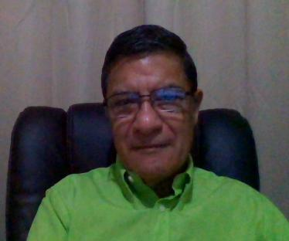 Raul Guerrero
Barrio San Pablo, 600 S. "La Rosita" *Quesada, San Carlos, Alajuela, Costa Rica (506)61071727 US digital (818) (506) 60824281 warriorraul@yahoo.com, Skype name: warriorraul
Objective
Position as a Language Translator / Proofreader/ Editor
Employment
FREELANCE TRANSLATOR and Editor 2002 - PRESENT
San Jose, Costa Rica
Infarom Publishers 2008 - PRESENT
Craiova, Romania
Community Tool Box August 2008
- Translation of social documents for WHO (World Health Organization)
RCI Vendor International April 2008
CAMBRIDGE, MA 02141-1014
- Editing job for an agricultural project in Costa Rica
Gospel Translations 2007-PRESENT
- Working as a volunteer translator for Gospel Translations at www.opensourcemission.com with religious written articles and books.
Spectrum Translations
The Netherlands 2006 - PRESENT.
F.C.B. Publishing Agency 2002–2005
San Jose, Costa Rica
Servicio Consular Católico Inc. 2003 - 2008
Los Angeles California
Education
High School Diploma 1970–1973
certificate in Translation 2005-2006
WLS, Words Language System (from English to Spanish)
Dublin, Ireland
PROFESSIONAL WRITER CERTIFICATE
AQI certified freelance translator 2007
jobs@arrowquality.com
Less than 10% of applicants make the certification
Savvy on many computer and Internet tasks; and manage all kinds of computer programs such as Trados, Wordfast, Across, etc.

Translation rates: Proofreading rates:
1000 USD70 1000 USD50
Minimum charge: Minimum charge:
USD15 USD10

