CURRICULUM VITAE

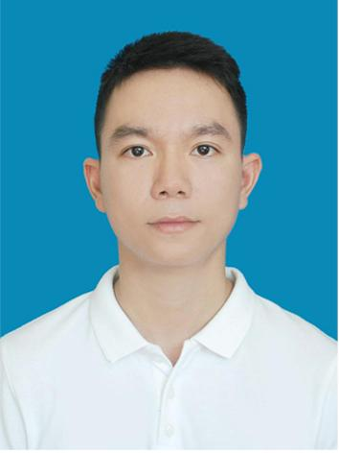
PERSONAL
Full name: Nguyễn Hữu Quang, Mr.
Date of birth: August 3rd, 1990
Cell phone: (84) 905 232 759
Email: quangnguyenhuu90@gmail.com
Address: 386/15D Phan Chu Trinh St., Hue City, Thua Thien Hue, Vietnam

EDUCATION
- B.A in English, Majoring in Interpretation
- Four-year-regular course
- Very good classification, GPA: 8.20/10 or 3.35/4
- Awarded in July 2012 by Hue University - College of Foreign Languages, Vietnam
- International Tour-guide License – English speaking
- Issued in 2014

WORK EXPERIENCE
- September 2012 – present: Translator and Interpreter, free-lance and Translation Pool of Hue Junior College of Pedagogy
- Translating diversified documents ranged in fields: literature, general news, official documents, contracts, receipts, and score-sheets… from English into Vietnamese and vice versa.
- Interpreting English – Vietnamese and vice versa in business meetings, social conferences (liaison and consecutive interpretation).
- Some considerable translation in my portfolio:
  - Project “Preserve Important Wetlands and Associated Habitats” by UNDP, ISPONRE – Ministry of Natural Resources and
  - Environment, the project is particular on Tam Giang – Cau Hai Lagoon in Hue and its local livelihoods (2015 – 2020).
  - VOA radio news (Vietnamese version) (2013-2014)
  - Thesis on “Issue Of Foreign Language Transcription In Philology And World Literature Textbooks – Actualities And Solutions” - Hoang Thi Xuan Vinh (2012)
  - World Investment Report (2012)
  - Business Registration application of Phu Thanh Spinning Joint Stock Company (2011)
- August 2014 – present: Tour operator and Tour guide, Buffalo Tours/ Discova Company
- Booking services for tours with precise programs
- Taking people on tours in Central Vietnam
- Researching and building new tourist products
- Providing customer care services to people on and after tours
- Every March from 2012 - 2015: Interpreter, “Vets with a Mission” Medical Program
- Interpreting conversations between doctors and patients
- Translating prescriptions and device manuals
- March 2013 – February 2014: Thriive Project Officer, Friends of Hue Foundation & Design Capital – Hue Fund
- Translating business’ loan applications and other related documents from Vietnamese into English and vice versa.
- Working on schedule, logistics (booking cars, boats; contacting businesses) for foreign donors, auditors and other guests of the organization.
- Liaison interpreting for Thriive foreign donors, auditors, other guests and Vietnamese business owners.
- Consulting and participating in the process of marketing and selecting 14 businesses to receive no-interest equipment loans at a value of nearly 115,000 USD in 2013.
- Managing 15 businesses on carpentry, handicraft, mechanics and construction industries in term of tracking their finance and job growth, and their loan repayment.
- Working on reports detailing business financials, job growth, and status on repayment on a quarterly, biannual and annual basis for program evaluation.
- Working on official documents to authorities and businesses.
- April 2012 – December 2012: Translator, interpreter and clerk, Department of Export, Import and Investment Promotion - Management Board of Chan May – Lang Co Economic Zone
- Translating contracts, speeches, and promotion documents.
- Liaison interpreting for leaders in their field trips with foreign investors.
- Managing official documents of Department of Import-Export and Investment Promotion.
- January 2012 – August 2014: English teacher (part-time job), Anh My English Center
- Teaching English for students of all ages
- Refining curricula for the Center
- Taking students out for more English practice opportunities
- June – July 2012: Co-leader of Vietnamese Delegation at Global Mountain Theater 2012, Telluride Academy, Colorado, United States

SKILLS
- Good English public speaking, interpretation and translation
- Proficient IT skills (SDL Trados Studio, Microsoft Office PowerPoint, Words, Excel, Outlook...)
- Teamwork and organizing
- Critical thinking
- Background knowledge of technology, education, business, tourism, history and culture
- Good story –telling skills

REFERENCES
- Nguyen Khac Dung, Manager in Central Vietnam, DISCOVA Tours Company
- Email: khacdung.nguyen@discova.com
- Duong Quynh Nhi, Manager, Design Capital – Hue Fund
- Email: abchanhnhi@yahoo.com.vn
- Nguyen Huu Cuong, Former Executive Officer, Translation Pool of Hue Junior College of Pedagogy
- Cell phone: (+84)905511887

