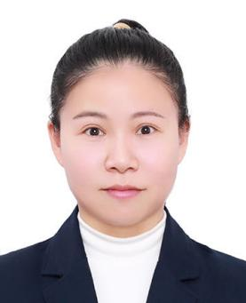

**RESUME**

***Qian Du | Freelance Translator (EN>CN)***

1. *mail: [sabrinadq2023@outlook.com](mailto:75829768@qq.com) Location: Wuhan, China*

**EDUCATION**

2006/09-2010/06 Hubei University of Technology Teaching Chinese As A Second Language B.A.

**CERTIFICATIONS&SKILLS**

**TRANSLATION EXPERIENCE**

* Certificated TEM8 (Test for English Majors-Band 8) - The Highest Level
* Certified CATTI (China Accreditation Test for Translators and Interpreters) English-Chinese Translator (Level II)
* Member of Translators Association of China
* Expertise in CAT tools and MS Office
* 2011: Published the translated version of the article *Waterproofing Concrete is Essential* on the periodical *CHINA BUILDING WATERPROOFING.*
* 02/01/2012-08/31/2012: Translated product information published on the export B2B platform.
* 04/01/2012-08/31/2012: Translated immigration visa applications for Can-Achieve.
* 10/08/2012-11/01/2014: Translated various requirement documents about DCS system for QOROS, a Chinese motor company.
* 01/04/2015-10/30/2017: Translated game texts and announcements for Youqu, a Chinese game company.
* 11/01/2017-12/30/2020：Participated in over 10 game translation projects and translated game texts, esports newsletters and gameplay tips for PTSGI.

**CLIENTS**

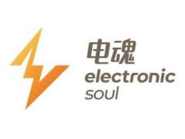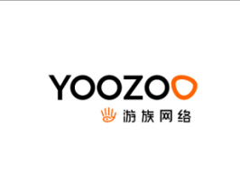1701331606912