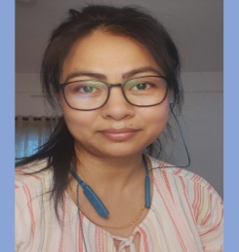 Pusparani Ph.D. Linguist
CONTACT  Phone  +91 7042989337  Location  Imphal West, India  Email  pusparani.puyam@gmail.com  SKILLS  - Have the proficiency to relate, understand and interpret in three languages Manipuri (native language), Hindi and English.  - Good in both verbal and written communications in the above three languages.  - Manipuri Transcription and Translation in both Bengali script and Meitei script  - Trained in voice recording, Data Collection, Data Entry, Data Analysis, Data Presentation,  - Familiar with MS Office, Excel, PowerPoint. | SUMMARY  Utilizing my subject matter expertise to offer the most accurate and efficient possible products, I enjoy English to Manipuri Translation work and I am passionate about Manipuri Transcription work.  PROFESSIONAL EXPERIENCE  - Worked in Central Institution of Indian Languages (CIIL), Mysore under the project ‘National Translation Mission (NTM)’ as a resource person cum translator for one year.  - A freelancer English to Manipuri translator since 17 years.  EDUCATION  - Ph.D in Linguistics, Manipur University, 2012 on the topic ‘Language Change in Meiteilon (Manipuri)’  - M.A. Linguistics, Manipur University, 2006.  - B.Sc. Manipur University, 2004  PERSONAL PROFILE  Languages: Manipuri, Hindi, English  Date of Birth: 21 September 1980  Gender: Female  Marital Status: Married  Nationality: Indian

DECLARATION-

I hereby affirm that all the above information in this document is true to best of my knowledge.

PLACE- Kolkata  DATE- 31 May 2024 | Signature:  Puyam Pusparani Devi

