A. Premkumar

Phone:+91 9884688898
Email:premkumar.asogan@gmail.com
Skype:Premkumar.asogan

Summary of Skills and Experience
Total Years of Experience |  |  | : 19 years
Mother tongue |  |  | : Tamil
Strong in |  |  | : Creative writing, Translation, Subtitling, Dialogue writing, script  writing, Anchoring, Voice over, AV production controlling, Handing  complete Pre & Post production of TV soaps, documentaries, short  films, Tele films and Ad films, creative team management.
Current Location |  |  | : Chennai, India

Work skills

Handling complete Audio/Video production independently. Experience in budget handling, finance controlling in Pre production and post production of documentaries, Telefilms, Ad films and short films.

Handling Content/editorial /creative departments independently.

Handling in-house teams, vendors and clients.

Subtitling - movies, web series, TV soaps and documentaries. Having knowledge and experience in accessing Online & Offline subtitling tools.

Proficiency in creating concepts for documentaries, short films, Ad films

Proficiency in English to Tamil Translation, creating content in Tamil.

Voice over & dubbing.

Willingness to learn: Keep on acquiring new skills through employment.

Teamwork: enjoy working in both team environments and independently.

Freelance contributions

Sub-titling for Netflix, Amazon Prime platforms.

Localized user guides, learner guides, explainer content.

Penned publications books, stories for magazines.

Created digital course curriculums for rural populace.

Career Path with Notable Contributions
» From Sep-2019, working as FREELANCE consultant
Work Profile:
- Translation, QC and subtitling for Netflix platform (Tamil Subtitles)
- Creating social media promo content for Sriram Properties
- Writing columns, News articles for ETV Bharat (Tamil)
- Writing scripts for Adithya TV (12 Tucker and Neengs sollunga dude)
- Creating Explainer/training video content for Madura Microfinance ltd.,
- Translation – Press releases, Insurance training PPTs etc.

» From March-2011 to Sep-2019 with Madura Micro finance ltd., as MANAGING EDITOR - Media & Communications
Work Profile:
- Heading Media & communications department.
- Taking care of Production of Digital course curriculums for Consumer literacy, Entrepreneur literacy and Numerical literacy courses for NSDC (National Skill Development Corporation) – An Indian govt. organization. These courses are rolling up via Madura microfinance network. The course comprises with Short films, documentaries and indoor explainer videos.
- Heading production and post -production teams. Handling entire budget and admin activities of documentaries /short film videos production.
- Creating concept, script for documentaries, corporate films, Short films on Women empowerment. Writing awareness materials in Tamil for rural populace.
- Coordinating with Vendors, freelancers, clients.
- Conducting workshops and training sessions for rural women entrepreneurs across Tamilnadu.

» From Dec-2008 t o J a n 2 0 1 1 with Chandamama (I)LTD., as Associate Editor – Online & Print
Work Profile:
- Heading Chandamama print division for 12 Indian languages. Co-ordinating with translators, Designers and DTP operators across the country.
- Doing linguistic and layout QC.
- Translating short stories from English to Tamil.
- Heading content department of Chandamama Tamil online (www.ambulimama.com ).

» From Sep-2006 to Nov- 2008 with WEBDUNIA.COM (P) LTD., as Language Lead -TAMIL

Work Profile:
- Heading Tamil Content team
- Translating User interface and User assistance environments. Localizing Help files and User guides.
- Creating Stories for portals.

» From Jan -2004 to August-2006 with DINAMALAR- national Tamil Daily as SUB-EDITOR
Work Profile:
- Creating stories and columns on national and International affairs. Translating PTI and UNI News to Tamil
- Taking care of supplement books and Special pages. created stories on politics and entertainment.

» From Mar- 2000 to Dec- 2003 with COMPUTER ULAGAM - Tamil Monthly Magazine, as SUB-EDITOR
Work Profile:
- Translating IT Related Articles, Computer user Tips and Series on various Topics.
- Doing content QC. Coordinating with freelance writers.
- Supervising DTP and designing team

Books

Penned books in Tamil for the rural populace.
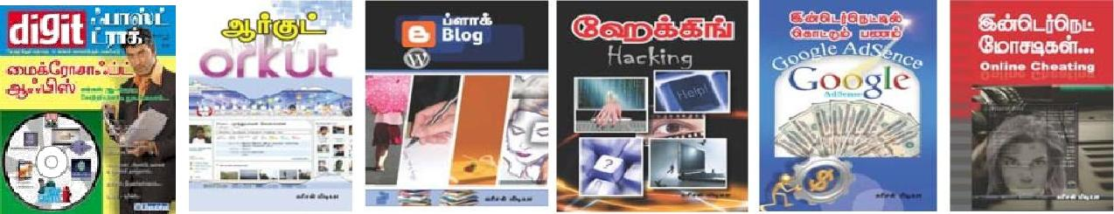

Educational Credential

B.A. (Economics) at Madras University, Chennai

GNIIT at NIIT, Chennai.

Diploma in Journalism at Madras University, Chennai.

DPQM (Diploma in Personal Quality Management) at NIIT, Chennai.

Diploma in Community Psychology, Alison academy

Personal profile

Date of Birth

08.05.1979

Languages Known

Tamil and English
Permanent address:

F-3, JBR FLATS,

16-A, Kupammal Street,

Kamarajar Nagar, Avadi,

Chennai -600071

Current address:

7/10, Golden treasure apartments,

Ambattur - vanagaram road,

Vanagaram, Chennai -600095

Credentials

Best IT Writer in Tamil. From South Indian Computers Manufacturers association

Best writer award. From Tamil Magazine publisher’s association

I do hereby declare that the above furnished information is true and accurate to the best of my knowledge.

Thank you

(A.Premkumar)

