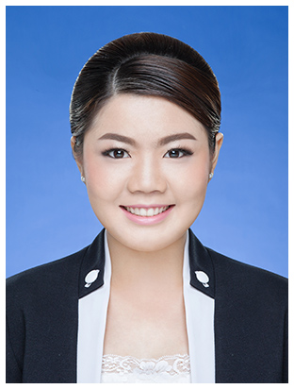
Miss Phachanon Cheevarungroj
85 Soi 6, Klongrian 2 road, Hatyai, Songkhla, Thailand 90110
Tel. +66-8-0037-9389 E-mail: phachanon.jane@gmail.com

Personal details : Date of Birth: August 5, 1991
Age: 24
Nationality: Thai
Religion: Buddhist
Height: 165 cm
Weight: 58 kg
Toeic score : 740
Expected salary: 25,000 baht

Work Experiences
2015: Freelance: Translator English-Thai
Thai Teacher for foreigners
2014: Assistant manager, Italian restaurant, Hatyai, Thailand
2014: Assistant foreigner teacher, Hello English, Hatyai, Thailand
2013: Waitress at Thai restaurant, Virginia Beach, Virginia, USA
2013: Summer Work and travel at Mcdonald’s, Virginia Beach, Virginia, USA
2012: Summer Trained Team Leader at Golden Foods Siam Limited, Chachoengsao, Thailand

Education .
2015: English Standard Course, Sprachcaffe Malta
2009-2013: Bachelor of science, Animal Science, Prince of Songkla University, Songkhla (GPA. 3.00)
2004-2009: Hatyaiwattalai 2 School, Songkhla

Activities .
2010: Committee of Photography Club

Special Skill .
Language skills: Good command of written and spoken English.
Computer: Microsoft office
Typing Skills: English (40 w/m), Thai (35 w/m)
Teamwork skills: easy to adapt with new environment of work with new people as I worked with people from different nationalities, a good listener and communicator with quick learning abilities

