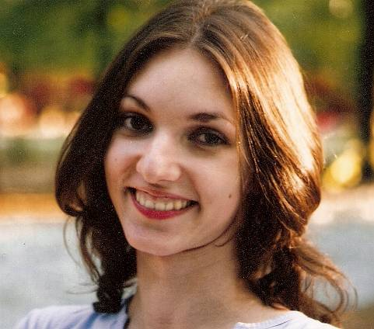
CURRICULUM VITAE

PetruŢa-DORA Grozavu

Date of birth: 29.04.1987
Phone number: 0751 094514
E-mail: dora.grozavu@yahoo.es

EdUCATION

North University Baia Mare, Philosophy – 2009 – 2012

North University Baia Mare, Romanian and European Contemporary Literature (2009 - 2011) Master degree

North University Baia Mare, Journalism (2006 - 2009) Bachelor degree

"Mihai Eminescu" National College, Baia Mare (2002-2006), bilingual profile (Romanian - English)

professional experience

1. Freelance Translator (2009 - present)
Different clients all over the world.
Responsibilities: translating articles, books and sites for different companies or persons, from English to Romanian and vice versa.

2. Forum moderator and Manager (December 2011 - present)
SC EUROSOFT SYSTEM SRL - “MarketGlory” – a strategy online game, with over 60.000 users. – “GoalTycoon” – a football manager game, with over 60.000 users.
Responsibilities: answering to the players’ questions, solving their problems, communicating efficiently with the team and with the users. Managing invoices, taking care of the office supplies, managing expenses. Writing unique content for these websites, promoting them online, writing specific SEO targeted content.

3. Content Writer (August 2012 - present)
Insite Collective
Responsibilities: Writing unique content for websites, writing specific SEO targeted content.

4. Designer (January 2012 – December 2014)
“Glasul Maramureşului” – local newspaper
Responsibilities: designing the pages of the newspaper in Quark XPress.

5. Journalist, Proofreader and Transcriber (2005 – 2012)
“Glasul Maramureşului” - local newspaper
Responsibilities: revising articles and transcribing handwriting and audio files, translating articles, writing articles.

6. Journalist (2007)
“Nou Horizont” - a magazine for the Romanian community from Spain:
Responsibilities: writing accurate articles for Romanian readers from Spain.

abilities

Driving license: B category, since December 2007
Foreign languages (writing/ speaking/ reading):
English (advanced, advanced, advanced)
Italian (medium, advanced, advanced)
Spanish (medium, medium, medium)

Computer skills:
Excellent computer skills: Word, Excel, Power Point, Internet, Photoshop, InDesign, QuarkXPress

Certificates: Professional certificate in English

Skills and abilities: sociable, communicative, polite, fast learning, team spirit, excellent knowledge of English grammar and vocabulary, common knowledge, distributive attention, attention to detail, analytical thinking, highly organized, imaginative, enterprising, ambitious.

Psychological skills: Efficient work even under stress, available for extra hours, meeting deadlines, motivated.

