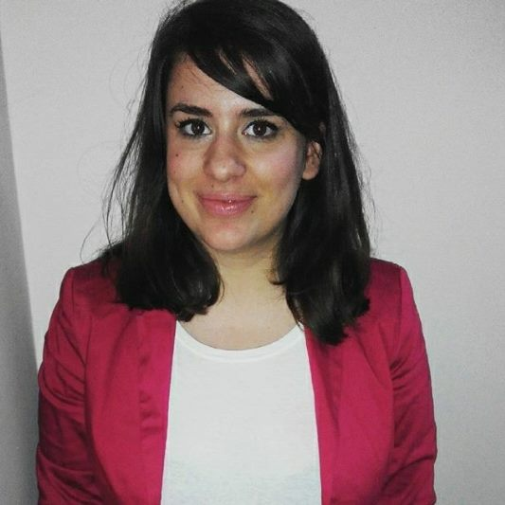
Petroula Georgousi
Mobile phone no +201098864467
E-mail address: petrinageo@windowslive.com
Nationality: Greek
Date of birth: 11/09/1993
Marital Status: Single

Education
9/2014 – 6/2015

9/2011 – 9/2016

Experience
1/2016 - present

Visiting student, Department of Modern Greek Language, University Paul Valery Montpellier 3 Montpellier, France (Erasmus scholar)

- Economical-Juridical Translation from French to Greek and vice versa

- Technical translation (engineering, medicine) from French to Greek and vice versa

- Literary Translation from French to Greek and vice versa

Department of Foreign Languages, Translation and Interpreting, Ionian University, Corfu, Greece
- Economical-Political-Juridical Translation from English to Greek and from French to Greek and vice versa.
- Literary Translation from English to Greek and from French to Greek and vice versa

Speak Up International Training Center (SUITC), English teacher to adults, Alexandria, Egypt

Languages
Greek
English

French

Spanish

IT skills
M/S Office, Mac

Native speaker

Advanced Level Certificate in English, Hellenic American University, 2009

Advanced Level Certificate in French, Hellenic Republic, Ministry of Education, 2009

level B1

