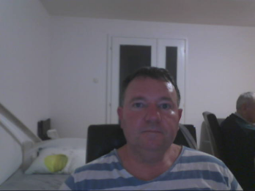
 |  | 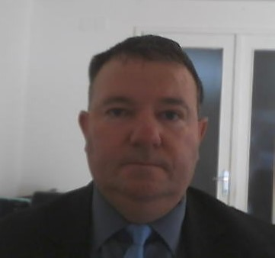
Europass
Biography
Personal data
Last Name / First Name |  | HARCA PETER
Address |  | Trg 1 Hrvatskog Sveučilišta, 42250, Lepoglava, Croatia ( Hrvatska )
Phone Number |  | Mobile Phone Number : +385 (0) 97 645 1442
Email |  | harcapeter@gmail.com
Citizenship |  | Croatian, Australian
Date of birth |  | 4.May. 1974
Sex |  | Male
Desired employment/occupation |  | Translator 0.035 Euro per word / Min per document 2 Euro  Transcriptionist 12,80 Euro per audio hour
Professional experience
Date |  | 2019
Occupation or workplace |  | Interpreter
Main jobs and responsibilities |  | I interpreted for Maria Berghofer in her infirmary, Croatian to English & English to Croatian
Name and address of the employer |  | Marija Berghofer.
 |  | Adlergasse 14, 8055 Graz, Austria. Tel : +43 699 17299857. Email : marie@vivacella.at
Dates |  | 2016 – 2023 Sporadic
Occupation or workplace |  | Interpreter
Main jobs & responsibilities |  | I interpreted for Kornelius Rohde is his clinic, English to Croatian & Croatian to English
Name of employer |  | Kornelius Rohde. Am Schlossberg 1, 84329, Wurmannsquick, Germany. Tel : +49 87256079955. Email : info@praxis-rohde.de
Dates |  | 2023 – 2024 Currently working for Voxtab as a QA/QC transcriptionist  2023 – 2024 Currently working for Gel-Global, Shenzhen, China as a translator. English to Croatian, also performing revisional tasks for them & giving an evaluation. They have given me a Willingness to Work Again.
Educational background |  | 1987-1992 High School, Box Hill Technical College
 |  | 1980-1986 Elementary school, Deepdene Primary School
Mother tongue |  | English
Second language(s) |  | Croatian, Bosnian, Serbian
Self assessment |  |  | Understanding |  |  |  |  | Speech |  |  |  |  | Writing
European level (*) |  |  | Hearing |  | Reading |  |  | Speech interaction |  | Speech production
Language |  |  |  | English |  | Good |  |  | Good |  |  | Good |  | Good
Language |  |  |  | Croatian |  | Good |  |  | Good |  |  | Good |  | Good
 |  | (*) Common European Framework of Reference for Languages
Social skills and competencies |  | I am enrolled in the Theocratic School,(organized by Jehovah's Witnesses) in front of a large number of people Reading the Bible publicly. And I also go into preaching, so I have contact with different people, the same is required in these tasks adaptability.
Computer skills and competences |  | Experience with Microsoft Word 2021, Trados 2022, MateCat, Memoq.
Driving licence |  | AM,B, F,G ( engine,car,tractor,)

