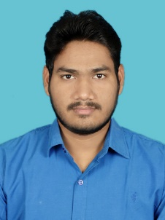
Curriculum vitae
Name : Pavan Ginnore
Email : ginnu.in@gmail.com
Contact No. : + 91-8819868974,+91-8770147883
Objective : To work in a challenging environment that provides various opportunities for learning & advancement in my career.
Academic Qualification :
Degree/Certificate | Qualification | Institution | University/Board | Passing Year | Aggregate % / CGPA
Graduation | B.E.  (E.C.E.) | Jabalpur Engineering College | R.G.P.V. | 2019 | 7.12
12th | Higher Secondary  (Science) | Saraswati Vidhya Mandir | M.P. Board | 2015 | 88.8%
10th | Secondary | Saraswati Vidhya Mandir | M.P. Board | 2013 | 82.5%
Projects:
- Minor project
Study of Iris recognition using wavelet transforms.
- Major project
Iris recognition using various templets.
Training:
- Major Training
Institution : Center for Research and Industrial Staff Performance
Course Title : PLC & SCADA
- Minor Training
Institution : Center for Research and Industrial Staff Performance
Course Title : EMBEDDED SYSTEM DESIGN
Certifications :
- Core Java certification
- C language certification
Skills :
- Subject : Microcontroller & Microprocessor
- Programming Language : Basic of c, Basic of Java
- Others : Transcription - Audio & Video, Video Captioning
Accolades :
- 1st rank in Roborace held by JEC.
- 3rd rank in state level Science model competition held by SVM ORG.

Personal Skills :
- Good Listener
- Innovative
- Creative
- A lot of patience
- Teamwork
- Trustworthy
Personal Dossier :
- D.O.B. : 26-Nov-1997
- Address : G-99/47,Tulsinagar,Near Van Bhavan Link Road No.2,Bhopal (M.P.)
- Language Proficiency :
- English : Read & Write
- Hindi : Read & Write
Declaration :
I hereby declare that above all information in the curriculum vitae is true to my knowledge.
Place : Bhopal Signature :
Date : 19-Nov-19

