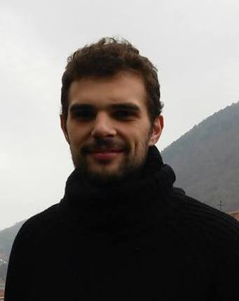
OLEKSANDR STRELCHUK
Address: Golovna 279b, Chernivtsi, Ukraine
Phone: +38(099)7883790
E-mail: alex-jo@ukr.net
Date of birth: 22 June 1992
Age: 23
Marital status: Single
Nationality: Ukrainian
Translator/Interpreter

Objective
Personal and professional development. Obtaining new skills in various spheres, including IT, Management, Marketing. Gaining new experience as a translator/interpreter.

Work Experience
2014-2015 Business analyst – IT company Cusbee (www.cusbee.co)
2011-2016 Freelance translator/interpreter

Education
2009-2015 Yuriy Fedkovich Chernivtsi National Univeristy, Ukraine
Master’s Degree in Foreign Languages,
Major in English, Minor in French and Spanish.
Bachelor’s Degree in Economy of Enterprise

Additional Education
2013-2014 Univeristy of Alicante, Spain
Business school for Entrepreneurs for 6 different domains
2014-2014 A.I.Cuza University of Iasi, Romania
Exchange program for English and French Translators

Languages
English - advanced
Spanish – upper-intermediate
French – upper-intermediate
Ukrainian-native
Russian-native

Personal qualities
Persistent, eager to learn, communicative, responsible, resultant, reliable.

