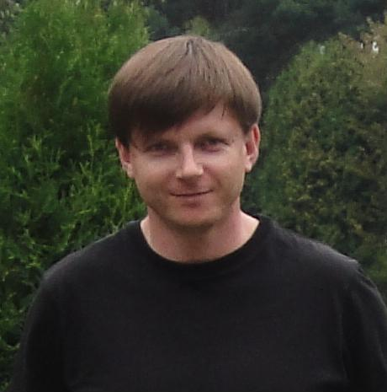
SKILLS
Key skills and competencies: excellent communication and social skills, able to work under tight deadlines and pressure, able to prioritise work
Languages: English, Polish, Ukrainian (native), Russian
Applications: 1C:Accounting, MS Office, SDL Trados, Translation Office 3000
OLEKSANDR
HONCHAR

PhD in Economics
Translator

Experienced
Flexible
Fast learner
Well organised
Attentive to details
Reliable and Responsible

Shafaryk Str. 8 ap. 161, Lviv, UKRAINE 79032
+38 (067) 370 35 81
figules@hotmail.com

EXPERIENCE
Translator – Freelance: 2002-2008, June 2011 – Present
Working freelance for direct customers, translation agencies and publishing house, USAID contractor.
Translation of books/documents/software.
Reviewing and proofreading mother-tongue text.
Subjects: business, legal, pharma, international relations, politics, technical.
Published literary translations (from English into Ukrainian): “Peter Pan” (J.M. Barrie), “The Roads We Take” (O’Henry), “Treasure Island” (R.L. Stevenson)

Senior Lecturer – Institute of Entrepreneurship and Innovation Technologies (Lviv National Polytechnic University): September 2011 – February 2014
Chair of Finance. Responsible for educational and methodological work, international cooperation of the Chair. Subjects:
Market of Financial Services
Financial Activity of Enterprises
Banking Services

Deputy MD for Finance - LLC “Mondi Packaging Bags Ukraine”, August 2008 – November 2010
Responsible for Administration, Finance, Tax&Legal, HR, IT and Procurement of Ukrainian branch of a multinational company.
Finance: KPIs monitoring, budgeting and planning, CI management
Tax & Legal: contracts management, Local Compliance Officer
HR: payroll and employment contracts management, employees training
Procurement: relations with suppliers, control of export/import

EDUCATION
Ph.D in Economics - Maria Curie-Sklodowska University of Lublin: 2003 –2008
M.Sc. in International Economic Relations; Translator - Ivan Franko National University of Lviv: 1997-2003

