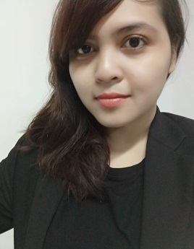
Curriculum Vitae

PERSONAL INFORMATION NINDYA KURNIAWATI
Via Piemonte 10
3515550750
nindya2012@gmail.com
Birth 28 September 1989 | Nationality Indonesia
WORK EXPERIENCE
October 2018 – March 2019 Cluster Public Relations Manager
Atria Hotel & Atria Residences Gading Serpong

- Managing Public Relations activities for both hotel and residences
- Supervised Graphic Design for monthly promotion design
- Maintain relations with media
- Maintain social media and website content
- Digital marketing activities
- Create Monthly reports
- Budgeting for advertisement and events

April 2017 – October 2018 Public Relations Manager (Pre-Opening)
Aston Imperial Bekasi Hotel & Conference Center

- Managing Public Relations activities
- Supervised Graphic Design for monthly promotion design
- Maintain relations with media
- Maintain social media and website content
- Digital marketing activities
- Create Monthly reports
- Budgeting for advertisement and events
- Responsible for creating monthly event at Sky Lounge

April 2016 – October 2016 Assistant Public Relations Manager
Kristal Hotel Jakarta

- Managing Public Relations activities
- Supervised Graphic Design for monthly promotion design
- Maintain relations with media
- Maintain social media and website content
- Digital marketing activities
- Create Monthly reports
- Budgeting for advertisement and events
- Responsible as PR Manager for the bar and create event based on the season

July 2015 – January 2016 Public Relations Officer (Pre-Opening)
Aston Imperial Bekasi Hotel & Conference Center

- Managing Public Relations activities especially branding
- Supervised Graphic Design for monthly promotion design
- Maintain relations with media
- Maintain social media
- Create Monthly reports
- Budgeting for advertisement and events

August 2014 – July 2015 Guest Relations Supervisor (Pre-Opening)
THE 1O1 Hotel Bogor Suryakancana

- Handling VIP guest
- Handling guest complain
- Daily Report for guest comment
- Express check in and check out for VIP guest
- In charge with Public Relations for weekly kids acitivity

February 2012 – July 2014 Translator (English – Indonesia)
STAR SOFTWARE Indonesia

Translating documents from English to Indonesia and vice versa with specific dateline

EDUCATION AND TRAINING
2007 – 2013 Bachelor of Communication in Public Relations and Journalism
Atma Jaya University Yogyakarta, Indonesia

- Public Speaking
- Psychology in Communication
- Brand Awareness and Launching
- Press Release
- Media Creating

2018 Hospitality Training by Archipelago International
Aston Imperial Bekasi, Indonesia

- Service Excellence
- Hygiene and Grooming
- Handling Complain
- Greeting Standard
- Basic Safety and Emergency Responses
- Email Etiquette
- Telephone Courtesy

